

STRATEGIC PLAN 2025 – 2030

March 2025

EXECUTIVE AUTHORITY STATEMENT

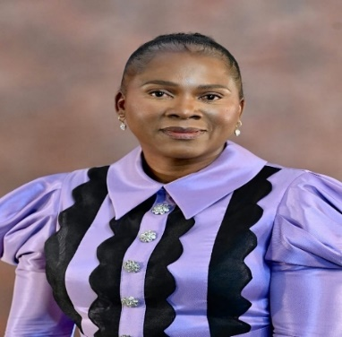
As we stand at a crucial juncture in our nation's history, it is essential to articulate a clear and purposeful path forward, one that reflects our collective aspirations and strategic priorities. This Medium-Term Development Plan embodies the Government of National Unity's commitment to fostering inclusive growth and job creation, addressing the urgent need to reduce poverty, and tackling the rising cost of living.

At the heart of our priorities lies the undeniable truth that sustainable development must serve all citizens, particularly the most vulnerable among us. We are called to intensify our efforts in the fight against poverty, ensuring that the most marginalized can access opportunities and improve their quality of life. This plan emphasizes our unwavering dedication to uplifting those who have long been underserved.

In pursuing these goals, we must confront and eradicate deeply rooted societal challenges, including gender-based violence, substance abuse and teenage pregnancy. It is imperative that we create an environment where all individuals, especially women and youth, can thrive without fear or limitation. By implementing targeted interventions and support systems, we aspire to build resilience and empower our communities.

Moreover, nurturing a capable, ethical and developmental state is paramount. We must inculcate the spirit of clean governance in every facet of our administration, ensuring transparency, accountability and integrity. This will foster public trust and encourage active participation from all sectors of society in the development process.
Through this strategic planning document, we reaffirm our commitment to these objectives. It is imperative to reaffirm our commitment to the electoral mandate bestowed upon us by the electorate. This mandate is not merely a reflection of our political ambitions; it is a solemn promise to the people who have placed their trust in us. The confidence shown by our citizens in this election cycle must not be taken lightly or allowed to fade into complacency. We invite collaboration, innovation and a shared vision as we work together to build a brighter, more equitable future for all. We are tasked with critical responsibilities of improving the quality of life of all citizens, particularly the poor and the vulnerable among us including those living with disabilities and older persons. We face numerous challenges but must forsake excuses. Our duty is clear: to create an inclusive society where everyone regardless of their circumstances has the opportunity to thrive. It is our moral obligation to ensure that the voices of the marginalized are heard and their needs addressed by the Department of Social Development.

There can be no excuses for inaction or negligence. The time for decisive action is now. We will hold ourselves accountable to the people we serve. We must witness tangible improvements in the lives of the poor and marginalized. It is our responsibility to ensure that the trust placed in us results in real, measurable change. Together, let us strive to honor our commitments and transform our vision into reality. We owe it to our people to deliver on our electoral mandate. We must spare no effort until the fundamental objective of our revolutionary course is achieved, A better life for all.

I therefore commit to my department that this Strategic Plan (SP) 2025-2030 shall be fully implemented to improve provision of services to the most vulnerable members of our society.

_______________________________________
Ms. F.F Radzilani
Member of the Executive Council
Department of Social Development

ACCOUNTING OFFICER STATEMENT
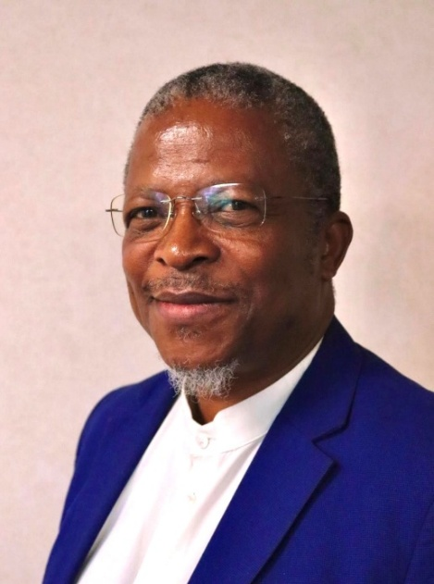

This Strategic Planning documents details the plans that the Department has for the 7th Administration. The department held a number of engagements develop and articulate the plans that will unfold for the next five years.

These plans are an expression of the Medium-Term Development Plan (MTDP 2024 – 2029) strategic priorities which are:

- Inclusive growth and Job creation
- Reduction of poverty and tackling the high cost of living
- Building a capable, ethical and developmental State

The Department recommits itself to improving and strengthening service delivery and clean administration in the 7th Administration.

The Department wishes to extend its unwavering appreciation for the Strategic and Technical support provided by the following role players in developing this Strategic Plan:

- National Department of Social Development
- Limpopo Province Office of the Premier
- Standing Committee on Public accounts (SCOPA)
- Portfolio Committee on Social Development
- The Audit committee
- Social & JCPS Clusters
- Risk Management Committee (RMC)
- Limpopo Provincial Treasury
- Shared internal audit Services (SIAS)
- National Development Agency (NDA)
- South African Social Security Agency (SASSA)
- Organized Labour
- Development Partners
- Limpopo Retired Social Workers
- Civil Society Organizations (CSO)
- NPO Forums
- Traditional Councils
- District and Local Municipalities
- Department of Planning Monitoring and Evaluation
- and many other community stakeholders

I therefore on behalf of the management of the department wish to make a commitment that this Strategic Plan 2025-2030 has also been fully aligned with the Limpopo Development Plan, Sector Priorities, and Provincial priorities.

_______________________________________
Dr MCAM Sehlapelo (Acting)
Accounting Officer
Department of Social Development

OFFICIAL SIGN-OFF
It is hereby certified that this Strategic Plan:
- Was developed by the management of the Department of Social Development under the guidance of Ms Fulufhelo Radzilani.
- Considers all the relevant policies, legislation, and other mandates for which the Department of Social Development is responsible.
- Accurately reflects the Impact and Outcomes which the Department of Social Development will endeavor to achieve over the period 2025-2030.

Programme 1: Administration Signature: __________________
Mr OP Nkanyane (Acting)

Programmes 2, 3 & 4: Signature: __________________
Ms NA Setlatjile

Programme 5: Development and Research Signature: __________________
Mr S.P Mulovhedzi (Acting)

Chief Financial Officer Signature: __________________
Mr M.G Matlala

Head Official responsible for planning Signature: __________________
Mr C.L Chuene

Acting Accounting Officer Signature: __________________
Dr MCAM Sehlapelo (Acting)

Approved by: Signature: __________________
Ms. F. F Radzilani
Executive Authority

TABLE OF CONTENTS
EXECUTIVE AUTHORITY STATEMENT 2
ACCOUNTING OFFICER STATEMENT 4
OFFICIAL SIGN-OFF 6
Part A: Our Mandate 10
1. Constitutional mandate 10
2. Legislative and Policy Mandates 10
3. Institutional Policies and Strategies over the five-year planning period 13
3.1 National and Province-wide Policies and Strategies 13
3.2 Departmental Policies and Strategies to Support Implementation. 15
4. Relevant Court Rulings 16
Part B: Our Strategic Focus 17
5. Vision 17
6. Mission 17
7. Values 17
8. The Mandate of the Social Development Sector 17
9. Strategic Mandates and Long-Term Planning Alignment 17
9.1 Sustainable Development Goals- SDG Agenda 2030 17
9.2 African Union-AU Agenda Goals: Agenda 2063 18
9.3 National Development Plan - NDP Vision 2030 18
9.4 Limpopo Development Plan (LDP) Priorities - 2025-2030 18
9.5 Medium Term Development Plan (MTDP) Strategic Priorities: 2024-2029 19
9.6 Sector Priorities 19
10. Situational Analysis 20
10.1 External Environment Analysis 20
10.2 Internal Environment Analysis 23
10.3 Demographic Data Analysis 24
11. Organisational Structure 33
11.1 Employment Equity Status Report as of 28 February 2025 34
11.2 Summary of the Social And Transformation Issues 36
Part C: Measuring our Performance 37
12. Institutional Performance Information 37
12.1 PROGRAMME 1: ADMINISTRATION 37
12.2 PROGRAMME 2: SOCIAL WELFARE SERVICES 42
12.3 PROGRAMME 3: CHILDREN AND FAMILIES 47
12.4 PROGRAMME 4: RESTORATIVE SERVICES 52
12.5 PROGRAMME 5: DEVELOPMENT AND RESEARCH 57
13. Key Risks 66
14. Public Entities 67
Part D: Technical Indicator Description (TID) 68
15. PROGRAMME 1: ADMINISTRATION 68
16. PROGRAMME 2: SOCIAL WELFARE SERVICES 70
17. PROGRAMME 3: CHILDREN AND FAMILIES 73
18. PROGRAMME 4: RESTORATIVE SERVICES 74
19. PROGRAMME 5: DEVELOPMENT AND RESEARCH 76
Annexure A: NSDF and the District Development Model: Infrastructure Projects 79
Annexure B: Processes for the Development of the Departmental Strategic Plan 2025-2030 and Annual Performance Plan 2025/2026 80

Part A: Our Mandate

1. Constitutional mandate
Schedule 4 of the Constitution states that provinces concurrently with national have the functional areas of legislative competence related to population development, urban and rural development, and welfare services. In line with Section 132 of the Constitution, the successive Premiers of Limpopo province have established the Department and assigned it the responsibility for Social Development to implement community development, population development, and welfare services programmes in the province. In that regard, the Department contributes to the following sections of the Constitution:
27. (1) Everyone has the right to have access to— (a) health care services, including reproductive health care; (b) sufficient food and water; and (c) social security, including, if they are unable to support themselves and their dependents, appropriate social assistance.
28. (1) Every child has the right— (a) to a name and a nationality from birth; (b) to family care or parental care, or to appropriate alternative care when removed from the family environment; (c) to basic nutrition, shelter, basic health care services and social services; (d) to be protected from maltreatment, neglect, abuse or degradation; (e) to be protected from exploitative Labour practices; (f) not to be required or permitted to perform work or provide services that— (i) are inappropriate for a person of that child’s age; or (ii) place at risk the child’s well-being, education, physical or mental health or spiritual, moral or social development;

2. Legislative and Policy Mandates
The following National Legislation and Policy documents form the legal and policy framework being implemented within the Department:
Relevant Legislation | Purpose of the Legislation
RSA Constitution Act no. 108 of 1996; Chapter 10; Section 26 & 27 | Calls for provision of services impartially, fairly, equitably and without bias. The policy provides a framework for the fulfilment of citizen’s right of access to sufficient food, water and social security. and serves as a guide to National, Provincial and Local government in pursuit of food and nutrition security at every level.
Social Assistance Act (Act no. 13 of 2004) | The Social Assistance Act, 1992 provides for the rendering of social assistance to persons, national councils and Social Development Organizations.
Social Service Professions Act, 1978 (Act no. 110 of 1978) | Promotes and regulates the practice of social service practitioners for social service professions.
White Paper for Social Welfare (1997) | Aims to transform social welfare services through developmental approach
Probation Services Act, 1991 (Act no.116 of 1991) | Provides for the transformation of the child and youth care system.
Domestic Violence Act (Act no. 61 of 2003) | Provides for the protection of the victims of domestic violence and the vulnerable members of the society.
The Child Justice Act (Act no. 75 of 2008) | Provides the framework for dealing with children in conflict with the law.
Older persons Act (Act no.13 of 2006.) | Provide framework aimed at the empowerment and protection of older persons and at the promotion and maintenance of their status, rights, well-being, safety and security.
Advisory Board on Social Development Act, 2001 (Act no. 3 of 2001) | Provides for a national advisory structure in the social development sector.
Non-Profit Organisations Act 71 of 1997 | This Act repealed the Fund-Raising Act, 1997, excluding the chapter that deals with relief funds, and provided for an environment in which non-profit organisations can flourish. The Act also established an administrative and regulatory framework within which non-profit organisations can conduct their affairs.
Cooperative Act no. 14 of 2005 | The Act promotes the development of sustainable cooperatives that comply with cooperative principles. It promotes equity and greater participation by black persons, especially those in rural areas, women, and persons with disability and youth in the formation of and management of cooperatives.
Children’s Act No. 38 of 2005 | Provides the framework for the care and protection of children.
Sexual Offences Related Matters Act no. 32 of 2007 | Provides for the regulation of sexual offences against vulnerable groups.
Revised White Paper on families in South Africa, 2021 | The white paper aims to strengthen families and improve socio economic development
Disaster Management Act no. 57 of 2002 | 27. (1) In the event of a national disaster, the Minister may by notice in the Gazette. Declare a national state of disaster if-- (a) existing legislation and contingency arrangements do not adequately provide for the national executive to deal effectively with the disaster: or (b) Other special circumstances warrant the declaration of a national state of (2) If a national state of disaster has been declared in terms of subsection (1) 1. The Minister may, subject to subsection (3), and after consulting the responsible Cabinet member. Make regulations or issue directions or authorize the issue of directions
Public Procurement Act no. 28 of 2024 | To regulate public procurement; to prescribe a framework within which preferential procurement must be implemented; and to provide for matters connected therewith.
Prevention and Combatting of Trafficking in Persons Act no. 7 of 2013 | To give effect to the Republic's obligations concerning the trafficking of persons in terms of international agreements
Prevention of and Treatment for Substance Abuse Act no. 70 of 2008 | to provide for a comprehensive national response for the combating of substance abuse; to provide for mechanisms aimed at demand and harm reduction in relation
Public Finance Management Act, no. 1 of 1999 | To regulate financial management in the national and provincial government; to ensure that all revenue, expenditure, assets, and liabilities of that government are managed efficiently and effectively.
Public Service Act no. 103 of 1994 as amended | To provide for the organisation and administration of the public service of the Republic.
Protection of Personal Information Act, no. 04 of 2013 | To promote the protection of personal information processed by public and private bodies.
Promotion of Access to Information Act, no. 2 of 2000 | Gives the constitutional right of access to any information held by the state and private body.
Promotion of Administrative Justice Act, no. 03 of 2000 | Ensures procedurally fair administrative actions.
South African Social Security Act, no. 09 of 2004 | To provide for the establishment of the South African Social Security Agency as an agent for the administration and payment of social assistance.
National Development Agency Act no. 108 of 1998 | To establish a National Development Agency aimed at promoting an appropriate and sustainable partnership between the Government and civil society organisations to eradicate poverty and its causes.

3. Institutional Policies and Strategies over the five-year planning period

3.1 National and Province-wide Policies and Strategies
Relevant Policies | Purpose of the Policy
National Development Plan, 2030 | Chapter 11 of the NDP requires that the Department of Social Development should spearhead the Social Protection to make sure there is alignment and coordination of Social Protection issues including addressing the challenges of eradicating poverty and reducing inequality.
Medium Term Development Plan (MTDP) 2025-2030. | The MTDP translates the NDP 2030 priorities into strategic priorities, interventions and targets for the defined five-year period whilst also taking into consideration the electoral mandate for that term of office
Limpopo Development Plan 2025-2030 | It is the overarching development strategy for Limpopo province for the next five years. It seeks to reduce poverty, unemployment and inequality through sustainable economic development, social development, and transformation.
White Paper for Social Welfare (1997) | The White Paper sets out the principles, guidelines, proposed policies, and programmes for developmental social welfare in South Africa.
Integrated National Disability Strategy,1997 | It provides for an integration of disability issues in all government development strategies, planning and programmes.
South African Policy for Older Persons, 2005 | To facilitate services that are accessible, equitable and affordable to older persons and that conform to prescribed norms and standards. Such services should empower older persons to continue to live meaningful lives in a society that recognizes them as important sources of enrichment, expertise, and community support
Convention on the Elimination of All forms of Discrimination against Women (CEDAW), 1979 | The Convention was adopted by the United Nations in 1979, this “Treaty for the Rights of Women” is also known as “CEDAW” and addresses the areas of legal rights, education, employment, health care, and violence against women, politics and finance.
Disability Policy 2006 | It recognizes that Persons with Disabilities are valuable human resources for the country and seeks to create an environment that provides them with equal opportunities, protection of their rights and full participation in society.
Beijing Declaration Platform for Action 1995 | It is a resolution adopted by the UN at the end of the Fourth World Conference on Women It is a visionary agenda for the empowerment of women. It is also one of the reference frameworks to analyse the situation of the women around the world and to assess the efforts of States in support of women’s empowerment.
Population Policy 1998 | It examines the current state and likely future directions of population policy in South Africa with reference to family planning activities set against the background of past and it also response to the changing socio-political situations in the country.
National Crime Prevention Strategy, 1996 | It provides the need to follow a developmental approach and inter-sectoral collaboration towards combating and addressing crime.
Minimum Standards for Residential Facilities on People with Disabilities, 2007 | They serve as a guide to individuals and families as to what they can reasonably expect of a residential service. They have been developed for the purposes of the registration and inspection of residential services for people with disabilities.
National Drug Master Plan 2019-2024 | It guides and monitors the actions of government Departments to reduce the demand for and supply of drugs and the harm associated with their use and abuse.
Policy Framework on Orphaned and Vulnerable Children, 2005 | It provides for a common agenda for mounting an effective response towards addressing the challenges posed by the HIV/AIDS epidemic. It outlines key actions that must be taken urgently, including the prioritization of support for orphans, vulnerable children and their families in the national policies, actions and plans.
National Food and Nutrition Security Policy (2013) | Policy for Food and Nutrition Security identifies four pillars of food security in South Africa namely, adequate availability of food, accessibility of food, utilization and quality of food and stability of food supply.
Policy On Social Development Services to Persons with Disabilities, 2018 | Ensure the provision of social development services to persons with disabilities to improve the overall quality of their lives.
White Paper on the Rights of Persons with Disabilities 2015 | Provide the framework for a uniform and coordinated approach by all government departments and institutions in the mainstreaming of disability across all planning, design, budgeting, implementation and monitoring of services and development programmes
Guidelines on Reunification services for Families 2012 | To facilitate the effective management of reunification services which promote uniformity and standardization among social services to families.
National Youth Development Strategy – Department of Youth, Women and Persons with Disability | The National Youth Development Strategy was developed as to tool for mainstreaming, empowerment, skills development and empowerment in respect of entrepreneurship for the  youth.
National Youth Policy 2020-2030 | The National Department of Social Development Youth Policy (NDSDYP) 2021-2030 is a Departmental policy aimed at effecting co-ordination and mainstreaming of youth development outcomes for youth programmes at national, provincial and local levels of Department Social Development within South Africa. The Policy is an extended arm of the macro–National Youth Policy 2020-2030 designed to co-ordinate Youth Development in South Africa across all level of Social Development and the sector.
Limpopo Youth Development Strategy 2018 | The strategy is set to change the lives of youth people of Limpopo through empowerment programmes implemented by various sectors and department.
National Framework Towards the Professionalisation of the Public Sector, 2022 | The framework aims to ensure that South African has a professional public sector and requires departments to implement measure to ensure that public servants act in a manner that will contribute to the achievement of the vision of the NDP 2030.

3.2 Departmental Policies and Strategies to Support Implementation.
Departmental Policies and Strategies | Significance
Monitoring and Evaluation Policy Framework, 2024 | Provide systematic mechanisms for the data Collection, collation, capturing, analysing, evaluation and dissemination of credible and reliable performance information for the attainment impact, outcomes, outputs interventions, improve decision making, planning and generate relevant knowledge.
Whistle Blowing Policy | To conscientize staff about fraud and corruption related activities or practices, and also to raise concerns and receive feedback
Departmental Preferential Procurement Policy, 19 January 2023 | To give effect to the implementation of the Preferential Procurement Regulations, 4 November 2022
Employee Health and Wellness Strategy | The strengthening of the employee health and wellness function will result in a more productive workforce with a greater sense of commitment, loyalty and elevated employee morale that will inevitably impact positively on the achievement of impact, outcomes, outputs and interventions
Risk Management Strategy | The Risk appetite of the department clearly articulated, and systems put in place to manage inherent, residual, and emerging risks within the context of tolerable, transfer, treatment and termination of the risks.
Preferential Procurement Strategy | To provide a mechanism through which the Department will realize the objectives of the Preferential Procurement Regulations and Policy
Clean Audit Strategy | Mechanisms put in place to improve and sustain positive audit outcomes on financial statement and performance information

4. Relevant Court Rulings
None

Part B: Our Strategic Focus

5. Vision
A caring and self-reliant society

6. Mission
Provision of integrated, comprehensive and sustainable social development services

7. Values
FUNDAMENTAL VALUES GUIDING THE DEPARTMENT
Accountability | Taking ownership for decisions and actions and accepting the consequences that come with them
Caring | Showing sympathy and concern; embodying heart for all stakeholders and beneficiaries
Equality and equity | Treating everyone fairly and equally
Human dignity | Respecting everyone’s human rights
Respect | Showing due regard for the rights and obligations of others
uBUNTU | Showing humanity to others

8. The Mandate of the Social Development Sector
The Social Development Sector provides social protection services and leads government efforts to forge partnerships through which vulnerable individuals, groups and communities become capable and self-reliant participants.

9. Strategic Mandates and Long-Term Planning Alignment

9.1 Sustainable Development Goals- SDG Agenda 2030
Goal 1 | End poverty in all its forms everywhere
Goal 2 | End hunger, achieve food security and improved nutrition and promote sustainable agriculture
Goal 4 | Ensure inclusive and equitable quality education and promote lifelong learning opportunities for all
Goal 5 | Achieve gender equality and empower all women and girls
Goal 8 | Promote sustained, inclusive, and sustainable economic growth, full and productive employment and decent work for all

9.2 African Union-AU Agenda Goals: Agenda 2063
Goal 1 | A high standard of living, quality of life, and wellbeing for all citizens
Goal 2 | Well-educated citizens and skills revolution underpinned by science, technology, and innovation
Goal 3 | Healthy and well-nourished citizens
Goal 18 | Engaged and empowered youth and children
Goal 13 | Peace, security and stability is preserved

9.3 National Development Plan - NDP Vision 2030
Chapter 11 | Social Protection
Chapter 3 | Economy and Employment
Chapter 9 | Improving Education, Training, and Innovation
Chapter 12 | Building Safer Communities

9.4 Limpopo Development Plan (LDP) Priorities - 2025-2030
MTDP 2024-2029 Priorities | LDP Priorities | LDP Strategic Outcomes
Priority 2: Reduce poverty and tackle the high cost of living. | Accelerate social change and improve the quality of life of Limpopo’s citizens | Inclusive growth for a just society
 |  | Reduced poverty and improved livelihoods
 |  | Reduced levels of crime and violence
Priority 1: Drive inclusive growth and job creation | Economic Transformation, Job Creation and International Cooperation | Increased employment opportunities
Priority 3: A capable, ethical and developmental state | Strengthen crime prevention and build safer communities  Transform public service for effective and efficient service delivery  Invest in human capital for a developmental state | A capable and professional public service

9.5 Medium Term Development Plan (MTDP) Strategic Priorities: 2024-2029
The following Strategic Priorities were Pronounced by the President in his opening of the 7th Parliament on the 18 July 2024 and the State of the Nation Address on the 6th February 2025.
Strategic Priority 1: | Inclusive Growth and Job Creation
Strategic Priority 2: | Reduce Poverty and Tackle the High Cost of Living
Strategic Priority 3: | Build a Capable, Ethical and Developmental State

9.6 Sector Priorities
- Transformed developmental social welfare
- Gender-based violence, Drugs and substance abuse
- Prioritising the social protection of children
- Comprehensive social security
- Sustainable community development interventions
- Integrated social protection information system

10. Situational Analysis

10.1 External Environment Analysis
PESTEL | Opportunities | Strategy to leverage on opportunities | Threats | Strategy to minimize impact of threats
Political | The implementation of the District Development Model to ensure coordination and integration of services between the three spheres of government has made it easier for the department to build better partnerships. | Develop and implement DSD District Development Model practice to ensure effective collaboration between stakeholders | Increasing number of community protests about service delivery by government entities. | Engage communities through Imbizos and dialogues to ensure that the Department contributes effectively to community needs
Political | Legislature through its various committees play a critical role in overseeing service delivery | Improve the quality and regular reporting to the oversight bodies to help them provide better oversight and improve accountability by the department | Tendency by other departments and municipalities to focus on their mandates | Department to take measure that ensure that it participates fully in EXCO Clusters and in IDPs and DDM committees thus building better working relationships with the departments and municipalities
Political | National government has identified reducing poverty and tackling the high cost of living as one of the three key priorities of the 7th Administration, thus increasing the profile of the Department of Social Development | The Department will develop key programmes to address poverty and leverage national communication to ensure it improves its service offering
Economic | Limpopo has many farming and tourism attractions that have the potential for communities to develop their own enterprises | The department will encourage and support Cooperatives that operate in the farming and tourism space thus relieving the impact of poverty and contributing to the creation of jobs. | Limpopo province has high levels of unemployment, particularly among the youth and women. With the little resources available to the department, there is less chance of impact. | The Department to ensure that its selection of job creation and poverty alleviation programme focusses on those that will have the biggest impact and are most likely to be sustainable.
Economic | The province has numerous NPOs and CBOs established and focusing in the reduction of poverty | Intensify capacity building programmes for NPOs and CBOs that are run by the department |  | Linking of youth and women with other agents such as SETAs and LEDA for vocational skills programmes
Social | There are donors, partners and NPOs willing to render social development services | Identify more partners and donors and create opportunities for them to link with NPOs | Increasing rates of social ills such as teenage pregnancy, substance abuse, and GBVF | Improve the department’s collaboration environment, particularly with municipalities and other civil society organisations.
Social |  |  | Mismanagement of funds by NPOs | Monitor implementation of the Funding prescripts to identify specific areas that NPOs need to be capacitated more.
Technology | Availability of social media platforms that could enable the department to engage those utilizing the platform | Develop a public engagement plan that takes advantage of social media | Some areas that the department operates from has poor network connectivity | Leverage on the ConnectSA programme to expand the network connectivity of those areas, through engagement with the Office of the Premier. IT connection in all service points within rural areas
Technology | New and advanced technologies such as artificial intelligence are available for the Department to implement some of its programmes | Enhance the department’s ability to utilizes new technologies for its programmes | Technology changes too fast for the employees to cope | Encourage employees to adopt continuous learning approach
Environment | Limpopo is located in an area that has a high level of sunlight that could be utilized for solar energy generation | The Department support community projects that take advantage of the Limpopo environment to generate food for themselves. | There is an increase in the number of natural disasters, that include heavy rains, drought, etc. | Enhance the disaster intervention plans that are atuned to ensuring that the service offerings of the Department do not fail due to the disaster.
Environment | There are many areas in the province that are conducive to agricultural productions |  | Inaccessible communities due to poor roads infrastructure impacting on service delivery. | Identify communities that are prone to being cut off and develop a plan to mitigate the impact of the reduced access.
Legal | The country has an independent and effective justice system | Department to use the justice system to enforce its mandate | Requirement to implement court judgements with inadequate resources | Develop a compliance capacity to minimize court judgements against the Department

10.2 Internal Environment Analysis
PFiLMS | Strengths | Strategy to sustain strengths | Weaknesses | Strategy to address weaknesses
Personnel | Skilled staff available | Continuous Performance Development | Non filling of vacated posts. | Prioritize filling of vacated posts.
Finance | Financial Systems and policies are in place. | Continuous proper implementation of policies and strategies | Ineffective budgeting practices | Establish a team to cost each service and provide a report that will improve the budgeting process
Infrastructure | Accessible infrastructure | Continuous maintenance of available infrastructure | Insufficient and dilapidated infrastructure | Development and implementation of infrastructure plan
Leadership | Despite the non-filling of key leadership positions, those acting have sustained the organization | Build multiple leadership layers within the department | Management is perceived by staff as having poor leadership (Culture survey results) | Develop and implement the recommendation of the culture survey.
Management | Supportive Management. | Continuous capacity building for management. | Non filling of Senior Management and supervisor posts. | Advertise and filling of Senior Management and supervisor posts.
Systems | IT, SCM and financial systems available | Continuous monitoring and implementation of the systems | Some specific social welfare services systems are non-functional due to lack of capacity | Capacity building to enhance service delivery Insufficient capacity for licensing official emails.
Systems | Availability of implementable electronic systems. | Build the capacity of staff to take advantage of the available systems | Non-utilisation of available National DSD systems due to non-availability of licenses.

10.3 Demographic Data Analysis
According to census 2022, the population of South Africa increased from 62 million in 2022 to 63.02 million in 2024 in terms of Mid-year Population estimates, July 2024. Females constituted 51,0% of the total population, while 49,0% were males. Gauteng and KwaZulu-Natal had the highest populations at 15.93 million (23.3%) and 12,31 million (19.5%) respectively, while the Northern Cape had the smallest 1,37 million (2.2%)
Whereas the Limpopo population size dropped from 6,572,721 in terms of the census 2022 to 6,402,594 in accordance with the Mid-year Population estimates, July 2024, which is a decline of 170 127 (3%). About 51.0% (3 265 322,94) are females and 49.0% (3,137 271 ,06) are males. Children constitute about 43% of the population, followed by Youth with 30%, adults 18%, and the elderly with 9%.

Figure 1: Limpopo Province Municipality demarcation by District and Local
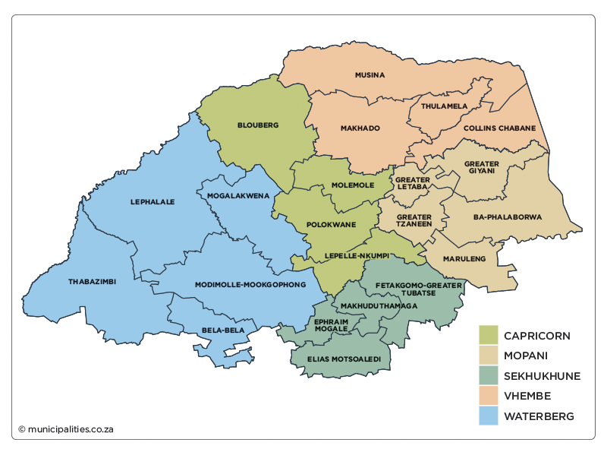

Table 1: Population distribution per age category
Age Distribution (Mid-year Population Estimates, July 2024) |  | Aggregated | Category | %
80+ years | 78 466 | 573 566 | Elderly | 9%
70-79 years | 179 947 | 573 566
60-69 years | 315 153 | 573 566
50-59 years | 457 682 | 1 143 179 | Adults | 18%
40-49 years | 685 497 | 1 143 179
30-39 years | 984 348 | 1 937 789 | Youth | 30%
20-29 years | 953 441 | 1 937 789
10-19 years | 1 321 477 | 2 748 061 | Children | 43%
0-9 years | 1 426 584 | 2 748 061
AGGREGATED | 6,402,594 |  |  | 100%
Source: Mid-year Population estimates, July 2024

Table 2: Population per group category
Population Group Population |  | %
Black African | 6,178, 503 | 96.5%
White | 160,065 | 2.5%
Other group | 64 026 | 1%
Aggregated | 6,402,594 | 100%

The highest population group is black African with 96.5%, whites constitute about 3% of the population and less than 1% of the groups.

Table 3: Disaggregated District Population per gender
Districts | Population Size | % | Male | Female
Districts | Population Size | % | No | No
Vhembe | 1 536 623 | 24 | 752 945 | 783 678
Capricorn | 1 472 597 | 23 | 721 573 | 751 024
Mopani | 1 280 519 | 20 | 627 454 | 653 065
Sekhukhune | 1 216 492 | 19 | 596 081 | 620 411
Waterberg | 898 363 | 14 | 440 198 | 458 165
Aggregated | 6,402,594 | 100 | 3 138 251 | 3 266 343

Chart 1 : Disaggregated District Population per gender

Vhembe District remains the highest in population size whereas Waterberg is the lowest.

Table 4: The table below is an analysis of population per age and type of services provided by the Department
Age | Category | Total | Type of Services
0-19 | Child Population | 2 748 061 | Partial care, Child Care and Protection, Community-Based Care Services, Family Preservation, Social Crime Prevention, HIV&AIDS, Persons with Disabilities, Substance Abuse and Research and Development.
20- 34 | Youth Population | 1 937 789 | Youth Development, Social Crime prevention, Victim Empowerment, Anti-Substance Abuse, Services to Families, Women Empowerment, Poverty Alleviation, Job Creation, Food Security, Sustainable Livelihoods, Persons with Disabilities, PO Capacity Building, HIV&AIDS and Research and Development.
35- 59 | Adult Population | 1 143 179 | Women Empowerment, Poverty Alleviation, Job Creation, Food Security, Sustainable Livelihoods, NPO Capacity Building, Victim Empowerment, Persons with Disabilities, Services to Families, HIV&AIDS and Research and Development.
60 + | Elderly Population | 573 566 | Services to Older Persons, Persons with Disabilities, Services to Families, HIV&AIDS, Substance Abuse, Victim Empowerment, NPO Capacity Building, Poverty and Sustainable Livelihoods and Research and Development.
Total | All Categories | 6 402 594

According to the General Household Survey 2023, the percentage of South Africa’s households that had limited access to food increased from 17,8% in 2019 to 23,1% by 2023. Simultaneously, the percentage of persons with more limited access to food declined from 19,5% in 2019 before increasing to 26,2% by 2023. It further shows that 23,1% of households, nationally, considered their access to food as inadequate or severely inadequate. Food access problems were most common in Northern Cape (37,7%), and North West (32,6%).
It is noted that only 6,9% (110 400) of food insecure households in Limpopo had inadequate or severely inadequate access to food. This is an increase from 5.5% (77 000) food insecure households in 2019 General Household Survey, this is translated to 662 400 people that are considered having inadequate or severely inadequate access to food. This situation was also worsened by the Covid-19 Pandemic where most people lost their source of livelihoods, where people were compelled to downgrade their eating lifestyles and habits. Source: GHS, 2019 and 2023.

COMPREHENSIVE ANALYSIS OF THE DEMOGRAPHIC FACTORS
- The poverty rate declined from 57.1% in 2022 to 56.0% in 2023 (GHS 2023).
- Limpopo remains one of the provinces with the highest poverty rates, alongside the Eastern Cape.
- The highest concentration of vulnerable people living in poverty is found in the following municipalities: Polokwane (361,638), Fetakgomo-Tubatse (240,591), Thulamela (265,324), Makhado (219,430), and Greater Tzaneen (211,413). Child-headed households in inadequate dwellings are predominantly concentrated in rural areas, particularly in Collins Chabane and Greater Giyani.
- The percentage of individuals receiving social grants increased marginally from 49.1% in 2022 to 50.4% in 2023, reflecting a growing reliance on social assistance. Conversely, the percentage of households benefiting from social grants decreased from 61.6% in 2022 to 60.7% in 2023, indicating a slight reduction in household-level dependency.
- The impact of the COVID-19 deaths is evident in the change in the population structure over the years 2020–2024 specifically in the elderly aged 60 and older.
- There is growth in various age categories except for the youth (those aged 15–24), all population age categories reflected a decline in the rate of growth between 2020 and 2021. The 2024 reflects changes in fertility, mortality and migration that occurred over decades.
- The more rural provinces of Limpopo and Eastern Cape indicate higher total fertility rates whilst more urbanized provinces such as Gauteng and the Western Cape indicate lower rates of fertility.
- Life expectancy at birth increased incrementally for each period across all provinces.
- The assumptions indicate that Gauteng and Western Cape received the highest number of in-migrants for all periods.
- Whereas Eastern Cape, Limpopo and Gauteng experienced the largest number of outflow of migrants for all periods.
- HIV prevalence is estimated at 12,7% of the total population nationally.
- A fifth of South African women in their reproductive ages (15–49 years) are HIV positive.
- HIV prevalence among the youth aged 15–24 has remained stable over time, declining marginally in the most recent decade.
- In accordance with the findings of research on “Factors associated with the increase of Gender Based Violence and Femicide incidents in the province” the key finding generally indicates a decrease in the perceptions of those who believe that it is justifiable for a man to beat his woman/wife/girlfriend as influenced by cultural beliefs that “if you do not beat up your partner it means you don’t love her”.
- It was also found that most perpetrators of GBVF are previous partner, relative or family member that is part of the household and to certain extend there are unknown persons or strangers that commit the most acts of gender-based violence and femicide. (Source: Governance, Public Safety, And Justice Survey GPSJS 2020/21, DSD GBVF Research Report 2023/24)
- The number of employed persons increased in seven provinces between Q2: 2024 and Q3: 2024. Employment gains were recorded in Eastern Cape (83 000), Western Cape (75 000), North West (69 000), Mpumalanga (49 000), Limpopo (33 000), Free State (30 000) and Northern Cape (23 000). Employment decreases were recorded in Gauteng (66 000) and KwaZulu-Natal (2 000) during the same period.
- Compared with Q3: 2023, the largest increases in employment were recorded in Free State (48 000), KwaZulu-Natal (46 000) and Mpumalanga (39 000). Eastern Cape was the only province that recorded a loss in employment with a decrease of 7 000 during the same period. Free State had the largest year-on-year percentage change increase in employment of 6,6%.
- The largest decreases were recorded in North West (4,5 percentage points), followed by Eastern Cape (3,8 percentage points) and Western Cape (2,6 percentage points). Increases in the unemployment rate were recorded in Limpopo (1,2 percentage points) and KwaZulu-Natal (0,1 of a percentage point).
- The expanded unemployment rate decreased by 0,7 of a percentage point in Q3: 2024 compared with Q2: 2024. All provinces recorded a decrease in the expanded unemployment rate, except for KwaZulu-Natal where the rate increased by 0,7 of a percentage point, and Gauteng where the rate remained unchanged. The largest decreases were recorded in North West (2,7 percentage points), followed by Eastern Cape (2,3 percentage points), Northern Cape and Free State (1,8 percentage points each) and Western Cape (1,7 percentage points). Compared with the same period last year, the expanded unemployment rate increased by 0,7 of a percentage point in Q3: 2024. Six out of the nine provinces recorded increases in the expanded unemployment rate. The largest increases in the expanded unemployment rate were recorded in Eastern Cape (3,5 percentage points), followed by Limpopo (1,2 percentage points) and Northern Cape and Mpumalanga (1,1 percentage points each). Decreases in the expanded unemployment rate were recorded in Free State (1,4 percentage points) and Gauteng (0,2 of percentage points), while Western Cape remained unchanged.
- The unemployment rate in Limpopo is as follows: Both sexes of Population 15-64 years is at 32.6% in Q3 compared to 31,4% in Q2 of 2024/25, Women unemployment rate is 45,7% in Q3 compared to 46.1% in Q2, Men 38,5% in Q3 compared to 39.5 in Q2 of 2024/25. (Source :Quarterly Labour Fource Survey, November 2024)

The Department of Social Development provides bulk of its services in partnership with NPOs and community stakeholders. The remnants of Covid -19 pandemic are so evident in poor communities’ and vulnerable households within the province. More people have become so dependent on services provided by the department and its agencies, South African Social Security Agency (SASSA) and National Development Agency (NDA), hence a massive mushrooming of Non-Profit Organizations (NPO’s) which result on an extreme pressure on the limited budget and other resources.
Due to high level of unemployment particularly amongst the youth, the province is experiencing an overwhelming incidence of social ills such as Genders based violence, substance abuse, teenage pregnancy, and crimes. Despite intensified proactive awareness campaigns, and victim empowerment support, these cases keep on rising uncontrollably.
The department has concluded research on the impact of funded DSD residential facilities where it was found that the inadequate budget and tools trade are seriously compromising effectiveness and the quality of services provided to older persons, persons with disabilities, children in conflict with the law, victims of Gender Based Violence and Femicide (GBVF). The improvement plan has been developed to turn the situation around including maximizing budget efficiency to augment budget for DSD residential facilities in 2024/25 financial year.
Thers is an additional burden on the demand for social services such as child care and protection, preservation services for families, psychosocial support, services to persons with disabilities, youth and women headed households, poverty alleviation, food security and job creation.
Despite all these external conditions, the department will endeavor to reprioritize its resources so as to continue providing the much-needed services to the most vulnerable individuals in keeping with its mandate, vision and values as enshrined in the National Development Plan, Limpopo Development Plan and five-year Strategic Plan of the Sector within the context of the District Development Model (DDM).
The mandate of the Social Development Sector provides Social Protection services and leads government efforts to forge partnerships through which vulnerable individuals, groups and communities become capable and self-reliant participants.
The department is providing its services through its skilled and experienced social services professionals such as Social Workers and Community Development Practitioners (CDP’s), funding is provided to Non-profit Organizations (NPO’s) to support the Department in the fulfilment of its Constitutional and Statutory functions, some of the services are procured through efficient Supply Chain Management processes such as the tools of traits (laptops, cellphones, etc.) in order to ensure speedy and convenient service delivery and there is effective and consistent collaboration with other Departments, Municipalities and Community Stakeholders.
The department regressed from unqualified audit outcome for the first time since 2019/2020 financial year and obtained a qualified audit opinion with material findings in 2023/2024 financial year. A clean audit strategy and improvement plan have been developed to resolve 13 remaining unresolved AGSA findings in order to improve the audit outcome in 2024/25 to 2029/2030.
The Clean Audit Strategy includes, amongst others the following internal control environment such as attending regular audit steering committee sessions, intensify monitoring the implementation of the audit action plan and prioritizing internal audit work and resolve the outstanding internal audit findings.
The department has been operating without the Head of Department since April 2023 and the post has been readvertised, it has been functioning without the Chief Director Corporate Services since October 2023 and the Chief Director Development and Research services vacated since April 2021. During 2023/24 and 2024/25 the department successfully filled the post of Director Protection Services and Director Polokwane Welfare Complex. The recruitment plan for 2025/26 to 2029/30 financial years shall include the recruitment and the appointment of the following positions, Director Infrastructure Management, Director Human Resources, Director Communication Services, Chief Director Corporate Services and Chief Director Community Development and Research. This recruitment drive shall go a long way in enhancing capacity for effective leadership and strategic management in order to improve service delivery performance and audit outcomes.
11. Organisational Structure
The top three tiers of the current organisational structure of the department are illustrated below:
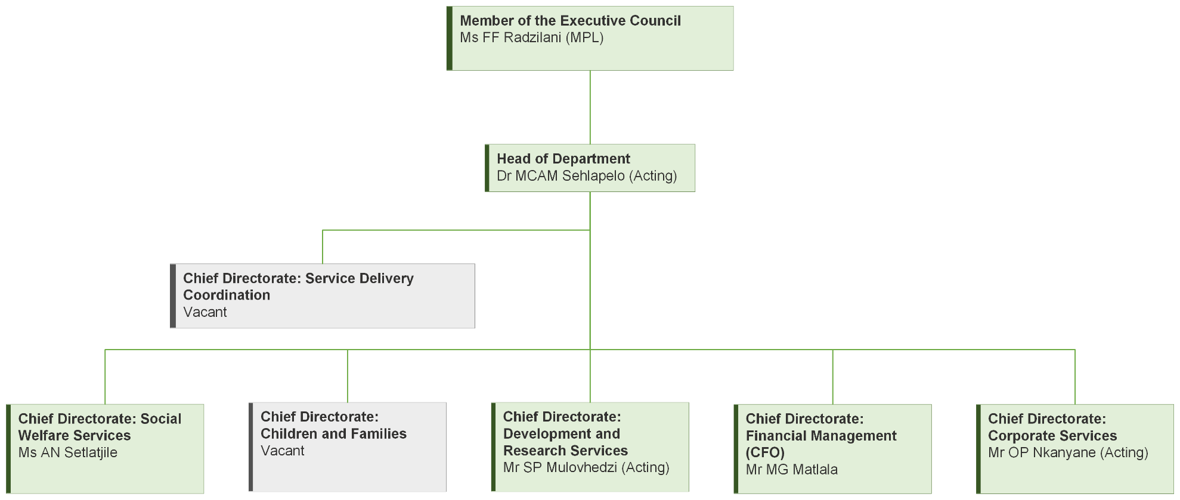

11.1 Employment Equity Status Report as of 28 February 2025
Table 7: Workforce Profile as at 28 February 2025
Occupational Band | Male |  |  |  | Female |  |  |  | Total
Occupational Band | African | Coloured | Indian | White | African | Coloured | Indian | White | Total
Top & Senior Management | 12 | 0 | 0 | 0 | 11 | 0 | 0 | 0 | 23
Professionally qualified and experienced specialists and mid-management | 182 | 0 | 0 | 0 | 520 | 0 | 1 | 7 | 710
Skilled technical and academically qualified workers, junior management, supervisors, foreman and superintendents | 423 | 0 | 0 | 0 | 910 | 0 | 0 | 0 | 1333
Semi-skilled and discretionary decision making | 170 | 0 | 0 | 0 | 343 | 2 | 0 | 0 | 515
Unskilled and defined decision making | 48 | 0 | 0 | 0 | 84 | 0 | 0 | 0 | 132
Interns/Contract Worker | 16 | 0 | 0 | 0 | 34 | 0 | 0 | 0 | 50
Total | 851 | 0 | 0 | 0 | 1902 | 2 | 1 | 7 | 2763

Designated Group | Salary Level | Target | Current Status as of 28 February 2025 | Gap | Progress | Intervention
Africans | 13-15 | 75% | 100% (23 of 23) | 25% | Department achieved the Cabinet Equity Target of 75% Africans at all Salary Levels. | Prioritise the appointment of other racial groups at all Salary Levels
Africans | 11-12 | 75% | 95.52% (64 of 67) | 20.52%
Africans | 9-10 | 75% | 99.22% (638 of 643) | 24.22%
Africans | 6-8 | 75% | 100% (1333 of 1333) | 25%
Africans | 1-5 | 75% | 99.69% (645 of 647) | 24.69%
Africans | Contract/ Interns | 75% | 100% (50 of 50) | 25%
Women | 13-15 | 50% | 47.82% (11 of 23) | -2.18% | Department did not achieve the Cabinet Equity Target of 50% Women in the SMS Level. | Prioritise the appointment of Women in the SMS Level.
Women | 11-12 | 50% | 49.25% (33 of 67) | - 0.75% |  | Prioritise the appointment of Women in the SMS Level.
Women | 9-10 | 50% | 76.98% (495 of 643) | 26.98% |  | Prioritise the appointment of Women in the SMS Level.
Women | 6-8 | 50% | 68.26% (910 of 1333) | 18.26% |  | Prioritise the appointment of Women in the SMS Level.
Women | 1-5 | 50% | 66.30% (429 of 647) | 16.30% |  | Prioritise the appointment of Women in the SMS Level.
Women | Contract/ Interns | 50% | 68% (34 of 50) | 18% |  | Prioritise the appointment of Women in the SMS Level.
People with Disabilities (PWD) | 13-15 | 2% | 0% (0 of 23) | - 2% | Department achieved the Cabinet Equity Target of 2% employed Persons with Disabilities (PWD). | a) Prioritise the appointment of PWD at all salary levels.  b) Intensify disability awareness campaigns and encourage employees to disclose their disability status.
People with Disabilities (PWD) | 11-12 | 2% | 2.98% (2 of 67) | 0.98%
People with Disabilities (PWD) | 9-10 | 2% | 0.62% (4 of 643) | -1.38%
People with Disabilities (PWD) | 6-8 | 2% | 2.17% (29 of 1333) | 0.17%
People with Disabilities (PWD) | 1-5 | 2% | 4.32% (28 of 647) | 2.32%
People with Disabilities (PWD) | Contract/ Interns | 2% | 0% (0 of 50) | -2%

11.2 Summary of the Social And Transformation Issues
Affirmative Targets | Target | Current Status as at  28 February 2025 | Progress
Percentage of Africans | 75% | 99.63% (2753 of 2763) | Achieved
Female at SMS level | 50% | 47.82% (11 of 23) | Not Achieved
People with Disabilities at SMS level | 2% | 0% (0 of 23) | Not Achieved
People with Disabilities at all Salary levels | 2% | 2.28% (63 of 2763) | Achieved

Part C: Measuring our Performance

12. Institutional Performance Information

12.1 PROGRAMME 1: ADMINISTRATION
The aim of the programme is to:
- Provide political and legislative interface between government, civil society and all relevant stakeholders.
- Provide overall strategic leadership, management and administrative services to the Department.
- Provides for the decentralization, management and administration of services at the District level within the Department.

The Department is not able to ensure good governance and attain clean audit outcomes. The current working conditions and lack of adequate resources continue to impact negatively on the Department.

12.1.1 Measuring the Impact
Impact Statement | Improved quality of life for the poor and vulnerable

Key Beneficiaries | - Non-Profit Organisations  - Departmental officials  - Stakeholders  - Service providers
Assumptions | - Improvement of working conditions and provisioning of resources will result in high productivity amongst employees and improved governance  - The Non-Profit Organisations will utilize the funds for the intended purpose.  - NPOs are complaint with relevant legislation and financial related prescripts.
National Development Plan (NDP) Goals and Objectives 2030 | - Social Protection  - Eliminate income Poverty: Reduce number of households with monthly income below R796 per person (in May 2024 prices) to zero  - Strategy to address Poverty and its impacts by broadening access to employment, strengthening social wage,
Limpopo Development Plan (LDP) Objectives 2025-2030 | - Accelerate implementation of EPWP and other intensive labour initiatives  - Implement a National Framework towards the professionalization of the public service  - Develop and implement the Limpopo Public Sector Human Resource Development (HRD) Strategy in the provincial public service  - Conduct institutional reviews, skills audit and capacity building to ensure that state institutions are execution driven in line with their mandates
Medium Term Development Plan (MTDP) 2024-2029 | Strategic Priority 1: Inclusive Growth and Job Creation  Strategic Priority 3: Build a capable, ethical and developmental state
Priority interventions | - Leverage of social security for local economic development  - Ensure that funds transferred through the overall social protection programme have a catalytic developmental impact on the wider community and on local economic development  - Implement public sector reforms to professionalize the public sector and improve delivery and efficiency  - Implement the Professionalization Framework across the public sector  - Improve accountability in respect of discipline, ethics, and integrity in the public sector  - Digitize and promote innovation in the public sector (implement an Integrated Human Resource Management System; improve efficiencies in the procurement and roll out of ICT initiatives in the public sector; streamline institutional arrangements for innovation)  - Implementation of retention strategy for all Occupational categories  - Leverage on available technology for service delivery and reduce need for office accommodation  - Implement e-recruitment  - Provision of tools of trade  - Enhance EHW services  - Reprioritize budget  - Prioritize appointment of key finance personnel  - Resolve audit findings.  - Conduct departmental quarterly pre-audit.  - Develop standard operating procedures to address contractual obligation.  - Adequately fund provision of ICT infrastructure.

12.1.2 Measuring the Outcome
Medium Term Development Plan Strategic Priority 3 |  | Build capable, ethical and developmental state
Outcome | Outcome Indicators | Baseline | Five-year targets
Functional, efficient and integrated sector | Percentage of women employed in SMS positions | 47.8% (11 of 23) SMS | 50% of women in SMS position
Functional, efficient and integrated sector | Percentage of persons with disabilities employed | 2.1% (61 of 2 852) Disability | 3% of people with disability employed
Functional, efficient and integrated sector | Number of material audit findings issued by the AGSA | 11 | 0
Functional, efficient and integrated sector | Percentage of procurement spent from designated groups | Women – 23%  (R57,028m of R249,687)  Youth – 15%  (R36,761m of R249,687m)  People with Disabilities – 0.03 % (R77m of R249,687m)  Military Veterans – 0.4%  (R99m of R249,687m) | Women – 40%  Youth – 30%  People with Disabilities – 7%  Military Veterans – 5%

12.1.3 Explanation of Planned Performance over the Five-Year Planning Period
- The contribution of outcomes towards the achievement of the Medium-Term Development Plan (MTDP), the mandate of the institution and priorities of women, children, youth and persons with disabilities, provincial priorities and Science Technology and Innovation (STI) Decadal plan priorities (2023-232) (where applicable).
The outcome on “Functional, efficient and integrated sector” shall contribute towards the achievement of MTDP Priority 3 “Build a capable, ethical and developmental state” as an endeavor to address Clean Administration and Good Governance. This will empower women, youth, and persons with disabilities by ensuring that women are part of the Senior Management Echelon of the Department to promote 50% of women appointed in the SMS position, and 3% of people living with disabilities. The implementation of preferential procurement strategies shall mainly benefit companies, cooperatives and NPOs managed by women, youth, persons with disabilities, and military veterans.
This shall further contribute towards the improvement of audit findings from qualified to unqualified and sustain the unqualified without matters of emphasis (Clean Audit).
The Decadal Plan proposes a transdisciplinary process to analyse, quantify and develop a set of impact measures that can be used to recalibrate, refocus and scale up the contribution of innovation to socio-economic development and expand the human resources capacity for STI. This intervention shall go a long way in keeping with the 4IR for effective service delivery.
- The rationale for the choice of the outcome indicators relevant to the respective outcomes.
The rationale for the choice of the outcome indicators is informed by the fact the department has been struggling for the past five years to achieve the equity target on women employed in SMS positions and that the audit outcome regressed from unqualified with matter of emphasis to qualified with matters of emphasis in 2023/24 Financial year.
- Explanation of enablers to achieve the five-year targets.
In the next five years the Department shall implement the following enablers to achieve the outcome, employment recruitment plan targeting women in SMS positions, preferential procurement strategy targeting women, youth, persons with disabilities and military veterans, as well as implementing Clean Audit strategy, strengthen and monitor execution of audit action plan for both internal and external audit.

- Explanation of the outcomes’ contribution to the achievement of the impact.
The outcome on “Functional, efficient and integrated sector” shall contribute towards the achievement of impact “Improved quality of life for the poor and vulnerable”. By achieving employment equity, preferential procurement and unqualified audit without matter of emphasis (Clean Audit).

12.1.4 PROGRAMME RECOURSE CONSIDERATIONS
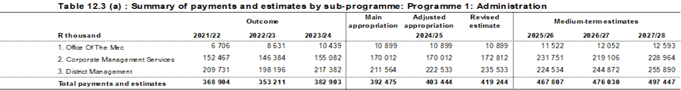
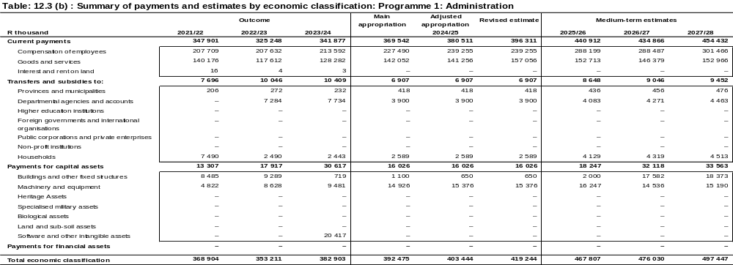
The budget for this programme has increased from R392.5 million in 2024/25 which is 19.2 percent to R467.8 million in 2025/26 financial year.
Compensation of employees increased by 26.7 percent from R227.5 million in 2024/25 to R288.2 million in 2025/26 financial year. An amount of R54.6 million was reprioritised from other economic classifications (Goods and Services and Capital Assets) to fund CoE pressures emanating from the higher than projected wage agreement.
Goods and services budget has increased by 7.5 percent from R142.0 million in 2024/25 to R152.7 million in 2025/26 financial year which is due to the reprioritisation from other economic classifications within the programme to fully fund CoE shortfall. An amount of R0.524 million and R1.0 million has been allocated from the fiscal sustainability addition to audit fees and security services respectively.
Payments for Capital Assets budget allocation has increased from the budget of R16.0 million in 2024/25 to R18.2 million and was therefore reprioritised fund CoE shortfall. The budget for building and fixed structures is not increasing except for the annual reprioritisation towards implementation of maintenance of facilities within goods and services given the progress on assessed maintenance plan by Public Works. An amount of R11.0 million has been reprioritised to CoE programme and R2.0 million to add to the ring- fenced allocation for maintenance of capital projects under goods and services.
An amount of R16.2 million under Machinery and Equipment has been set aside to cater for payment of finance leases for rented photocopiers, acquisition of motor vehicles and office equipment.

12.2 PROGRAMME 2: SOCIAL WELFARE SERVICES
The aim of this programme is:
Provide integrated developmental social welfare services to the poor and vulnerable in partnership with stakeholders and civil society organisations.
- Design and implement integrated services for the care, support and protection of older persons.
- Design and implement integrated programmes and provide services that facilitate the promotion of the well-being and the socio economic empowerment of persons with disabilities.
- Design and implement integrated community based care programmes and services aimed at mitigating the social and economic impact of HIV and Aids.
- To respond to emergency needs identified in communities affected by disasters not declared, and or any other social condition resulting in undue hardship.

The Limpopo mid-year population estimates are at 6,572,721 with older persons population size aged 60 and above estimated at 671 671 which is 10% of the total population which accounts to 164 327 males (30%) and 371 315 females (69%) (mid- year population estimates, 2022) and only 15 310 have benefited from DSD programmes which account to (26%). However, there is still high prevalence of Abuse and neglect of older persons by family and community members.

About 1.8 million population in Limpopo are persons with disabilities and only 3 844 have benefited from DSD programmes which account to 2.6%, and there is high prevalence of Abuse and neglect of persons with disabilities by family and community members.
According to the data from SANAC Situation Room -Public and Private Sector -April 2024, the Provincial HIV Cascade performance in achieving the 95-95-95 targets falls below expectations. Currently 717 039 people are living with HIV, and 660 578 (92%) of clients know their HIV status, with 479 346 (73%) of clients on antiretroviral therapy (ART), and 389 674 (93%) of those on treatment whose Viral Loads have been done are virally suppressed. This indicates a commendable effort in initial diagnosis and effective management of the virus.

The Province is on track to achieve the 1st 95% and 3rd 95%, the challenge is on the 2nd 95%.There is still a substantial gap in achieving optimal treatment coverage and this has a great influence on the 3rd 95% .The performance of <15years on ART is sitting at 72% against the target of 95%, revealing the gap to target of 5 576, however an estimated 6 786 children under 15 years are living with HIV and do not know their HIV status. Provincial performance reveals 63% Viral Load Suppressed of children under 15 with 6 232 individuals tested, revealing that 3 739 are not virally suppressed; the existing gap to the target of 20 756 is 14 524.
The Department targeted to reach 449 400 in the year 2019-2024 and only 273 269 beneficiaries were reached through DSD HIV and AIDS programmes. There is a need to allocate more resources and strengthen prevention programmes and psychosocial support. Services to reach more children and youth as they account for most of the population.

12.2.1 Measuring the Impact
Impact Statement | Improved quality life for the poor and vulnerable

Key Beneficiaries | - Older persons 60 +  - Persons with disabilities (all forms of disabilities)  - Persons infected and affected by HIV and AIDS and other key populations  - People in distress (individuals, families and communities)
Assumptions | - Older persons, people with disabilities and people living with HIV are the most vulnerable and requires care and protection.
National Development Plan (NDP) Goals and Objectives 2030 | Social Protection  - Protection for all vulnerable children; provide a comprehensive package of services including nutrition, immunisation, care, and stimulation
Limpopo Development Plan (LDP) Objectives 2025-2030 | - Implement targeted poverty alleviation programmes
Medium Term Development Plan (MTDP) 2024-2029 | Strategic Priority 2: Reduce poverty and tackle the high cost of living
Priority interventions | - Social protection to the vulnerable and the poor  - Safety, social cohesion, and food security.  - Accelerated social protection interventions through provision of psychosocial support to vulnerable groups

12.2.2 Measuring the Outcome
Outcome | Outcome indicator | Outcome Baseline 2019-2024 | Outcome (5) Five Year Target 2025-2030
Optimized social protection and coverage | Older persons accessing services within DSD Programmes | 15 839 | 16 841
Optimized social protection and coverage | Persons with disabilities accessing services within DSD Programmes | 4 134 | 4 220
Optimized social protection and coverage | People infected and affected by HIV and AIDS accessing services within DSD programmes | 273 269 | 506 750
Optimized social protection and coverage | Beneficiaries affected by any form of disaster and undue hardship receiving social relief programmes | 9 913 | 18 900

12.2.3 Explanation of Planned Performance over the Five-Year Planning Period
a) The contribution of outcomes towards the achievement of the Medium-Term Development Plan, the mandate of the institution and priorities of women, children and people with disabilities, provincial priorities of women, children, youth and persons with disabilities, provincial priorities and Science Technology and Innovation (STI) Decadal plan priorities (2023-232) (where applicable).

The Outcome will contribute towards strategic priority 2, “Reduce poverty and tackle the high cost of living” as well as ensuring Comprehensive Social Protection to the most vulnerable individuals in the society such as persons with disabilities, Older Persons and people infected and affected by HIV and AIDS.

Improved provisioning of statutory services for the aged, women, children and people with disabilities as well as the NDP five-year Implementation Plan outcome envisioning a “Reformed social welfare sector and services” that uphold, promote and protects the rights of vulnerable groups.

The Decadal Plan proposes a transdisciplinary process to analyse, quantify and develop a set of impact measures that can be used to recalibrate, refocus and scale up the contribution of innovation to socio-economic development and expand the human resources capacity for STI. This intervention shall go a long way in keeping with the 4IR for effective service delivery.

b) The rationale for the choice of the outcome indicators relevant to the respective outcomes.
The rationale for the choice of the outcome indicators relevant to the respective outcomes is informed by the high levels of incidences of neglect, abuse of older persons, persons with disabilities and high prevalence of HIV and AIDS amongst the youth and children.

c) Explanation of enablers to achieve the five-year targets.
To ensure that the 5-year targets will be achieved, the Department will appoint and train Social Service Professionals to implement the programmes. Fund NPO’s (civil society organizations) and empowering community stakeholders. As it has done previously, the Department will enter into Memorandum of agreement with other Partners.

- Explanation of the outcomes’ contribution to the achievement of the impact
The Outcome will contribute towards full protection of vulnerable persons against neglect, abuse and HIV and AIDS infection hence the achievement of the active ageing, long and healthy life amongst people with disabilities, older persons and youth and reduction in the new HIV/AIDS infections/incidence

12.2.4 Programme Resource Considerations
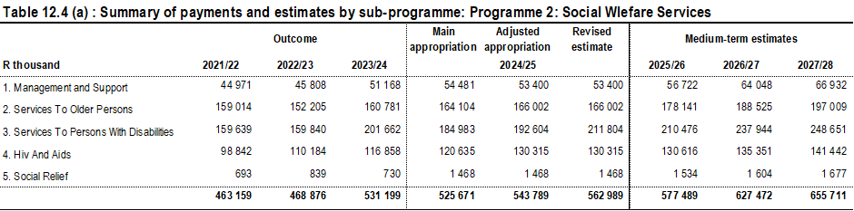

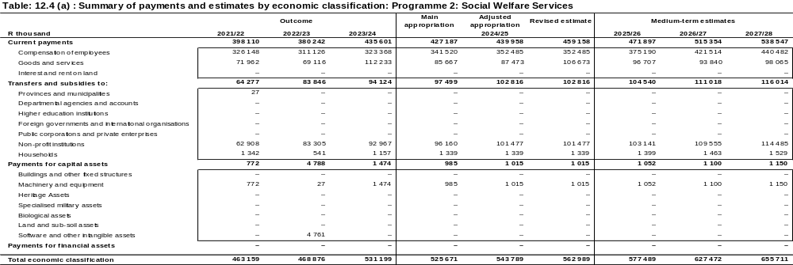
The budget for this programme has increased from R525.7 million in 2024/25 to R577.5 million in 2025/26 which is 9.9 percent.

Compensation of Employees budget increased from R341.5 million in 2024/25 to R375.2 million or 9.9 percent in 2025/26 financial year due reprioritization of R17.1 million from goods and services to fully fund the CoE pressures emanating from the higher than projected wage agreement.
The budget for goods and services has increased by 12.9 percent from R85.7 million in 2024/25 to R96.7 million in 2025/26 financial year to fully fund. However, the baseline of goods and services in 2025/26 financial year has decrease from R105.6 million to cater for CoE. The main contributor for budget growth is from Agency and support as contractual obligation for R61.0 million including the additional allocation share from fiscal sustainability addition for R3.5 million and R0.500 million for food and food supplies under Sekutupu Old Aged Home.
Transfers and subsidies increased by 7.2 percent from R97.5 million in 2024/25 to R104.5 million in 2025/26 financial year. The provision is made for transfers to Non-Profit Organisations under Older Persons sub-programme.
Payments for Capital Assets allocation has increased by 6.8 from the budget of R0.985 million in 2024/25 to R1.052 million in 2025/26 financial year. An amount of R1.052 million under Machinery and Equipment has been set aside for procurement of tools of trade for employees.

12.3 PROGRAMME 3: CHILDREN AND FAMILIES
The aim of the programme is to:
- Implement programmes and services to promote functional families
- Implement integrated programmes and services that provide for the development, care and protection of children
- Provide comprehensive partial care services
- Provide alternative care and support to vulnerable children
- Provide protection, care and support to vulnerable children in communities

The Limpopo mid-year population estimates are at 6,572,721, with child population (0-4) of 671 145, youth population (20-34) of 1 492 484, total population for adults (35-59) of 1 441 789, older person’s population of older persons (60 years +), and according to census 2026, persons with disability population (all ages) was 1 799 739.
Children in Limpopo face numerous challenges that render them vulnerable due to death of biological parents/ guardians/caregivers, unemployment, teenage pregnancy, drug and substance abuse. Interventions were rendered to 2 032 children in reported cases of child abuse, neglect, exploitation, child abandonment and violence against children. A total of 42 830 orphans and vulnerable children in need of care and protection were placed in foster care, and 4 382 children accessed psychosocial services in child and youth care centres. Through community-based care services, 171 608 orphans and vulnerable children accessed prevention and early intervention services at drop-in centres.
Families in Limpopo are faced with number of challenges which impact negatively on their ability to sustain themselves. Such challenges are partly related to poverty, unemployment, lack of integrated basic services, poor infrastructure and social ills. By 2024, the department provided care and support to 285 630 families which contributed to preservation and re-unification services and parenting programme.
ECD programme migrated to Department of Basic Education in 2021 /2022 financial year and the department remained with partial care and respite care. The department reached 4 227 children which contributed towards improved early childhood development (ECD) access to quality early learning.
Comprehensive services were provided to children and families within communities. The programme achieved the five-year targets through collaboration in partnership with various stakeholders, civil society organizations, and public private partnerships’ initiatives.

12.3.1 Measuring the Impact
Impact Statement | Improved quality life for the poor and vulnerable

Key Beneficiaries | - Families  - Children
Assumptions | Increased social ills that impacts negatively on children and families
National Development Plan (NDP) Goals and Objectives 2030 | Social Protection  - Protection for all vulnerable children; provide a comprehensive package of services including nutrition, immunisation, care, and stimulation
Limpopo Development Plan (LDP) Objectives 2025-2030 | - Implement targeted poverty alleviation programmes
Medium Term Development Plan (MTDP) 2024-2029 | Strategic Priority 2: Reduce poverty and tackle the high cost of living
Priority interventions | - Ensure roll-out of basket of social services to families caring for children and adults of disabilities regardless of geographical location  - Introduce measures to ensure early development screening for all children, and clearly defined eligibility criteria to reduce exclusion errors for social assistance support for children with disabilities

12.3.2 Measuring Outcomes
Outcome | Outcome indicator | Outcome Baseline 2019-2024 | Outcome (5) Five Year Target 2025-2030
Optimized social protection and coverage | Family members participating in family preservation services. | 285 630 | 95 200
Optimized social protection and coverage | Children provided with care and protection services. | 225 078 | 66 178

12.3.3 Explanation of Planned Performance over the Five-Year Planning Period
(a) The contribution of outcomes towards the achievement of the Medium-Term Development Plan, the mandate of the institution and priorities of women, children and people with disabilities, provincial priorities of women, children, youth and persons with disabilities, provincial priorities and Science Technology and Innovation (STI) Decadal plan priorities (2023-232) (where applicable).The Outcome will contribute towards strategic priority 2, “Reduce poverty and tackle the high cost of living” as well as ensuring Comprehensive Social Protection in the form of Child Care and Protection to children 0-18yrs.

The Decadal Plan proposes a transdisciplinary process to analyse, quantify and develop a set of impact measures that can be used to recalibrate, refocus and scale up the contribution of innovation to socio-economic development and expand the human resources capacity for STI. This intervention shall go a long way in keeping with the 4IR for effective service delivery.

(b) The rationale for the choice of the outcome indicator is informed by the high number of orphaned, vulnerable, abused and neglected children and dysfunctional families.
There are social ills which subject the department through its mandate to provide alternative care and support to the poor and vulnerable children within families. The services will amongst others include encouraging family members to participate in parenting programmes, get reunited with their families and engage in preservation services.

(c) Explanation of enablers to achieve the five-year targets.
To achieve the set five-year target, the following enablers will be established, capacity building of Social Service Professionals, funding of civil Society Organisations, empowering community stakeholders and enhancing Public Private Partnership’s initiatives.

(d) Explanation of the outcomes’ contribution to the achievement of the impact
The Outcome will contribute towards Improved access to partial care centres, Care and Protection Services to vulnerable children and sustain family resilience.

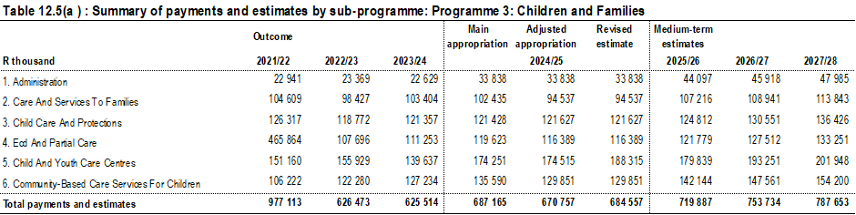
12.3.4 Programme Resource Considerations

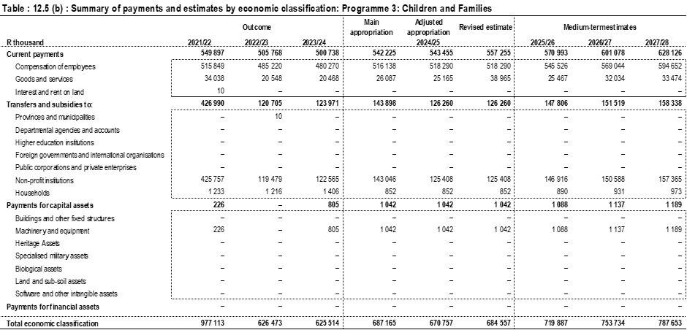
The budget for Children and Families programme has increased by 4.8 percent from R687.2 million in 2024/25 to R719.9 million 2025/26 financial year.
Compensation of employees has increased by 5.7 percent from R516.1 million in 2024/25 to R545.5 million in 2025/26 financial year due cpi increase and the and R3.6 million reprioritized from goods and services. The budget provision is meant for payment of salaries per headcount cost.
Goods and services decreased from the budget of R26.1 million in 2024/25 to R25.5 million or 2.4 percent in 2025/26 due to the reprioritization to fully fund CoE shortfall. The cost drivers for goods and services is the outsourced kitchen services or catering for CYCCs which was considered for the share of fiscal sustainability additional allocation for R0.500 million.
Transfers and subsidies have increased from R143.9 million in 2024/25 to R147.8 million or 2.7 percent in 2025/26 financial year to fund the non-profit organizations for Families, Partial care, CYCCs and Community Based Care services for children.
Payments for Capital Assets budget increased by 4.4 percent or R1.042 million in 2024/25 to R1.088 million in 2025/26 financial year. The budget increase will cater for running procurement of tools of trades for all departmental CYCC’s institutions.

12.4 PROGRAMME 4: RESTORATIVE SERVICES
The aim of this programme is:
- Develop and implement social crime prevention programmes and provide probation services targeting children, youth and adult offenders and victims within the criminal justice process.
- Design and implement integrated programmes and services to support, care and empower victims of violence and crime in particular women and children.
- Design and implement integrated services for substance abuse, prevention, treatment and rehabilitation.

According to the crime statistics report by SAPS, Limpopo has recorded increased crime incidents between October and December 2023. Overall crime in Limpopo has increased by 0.7%. This translates to more than 28,000 cases reported between in the reporting period. The cases have increased by 186 compared to the same period in the previous year
Since 2019- 2023, there has been an increase to 15 393 children who were charged which is 0.8% of the total child population.
The Department of Social Development assessed 8 529 children in conflict with the law between 2014-2019. The majority of crimes committed are common assault, theft, public violence and indecent assault. The main causes for committing crimes are related to abuse of substance such as alcohol and drugs. To a certain extent it can further be attributed to poverty, lack of parental care and supervision.
There is no accurate and reliable data that shows the nature and extent of the drug problem in the Province. The United Nations Office on Drugs and Crime reports that, nationally 10.3% of the adult population (15 years and older) are estimated to consume alcohol at harmful levels (16.5% of men and 4.6% of women) and 8.6% (13.3% of men and 4.1% of women) are estimated to use illicit drugs. Of those who use psychoactive substances, a large number will develop substance abuse problems. Substance Abuse contributes significantly to global illness, disability and death. Injection drug use contributes significantly to the transmission of serious communicable diseases such as hepatitis C and HIV/AIDS.
According to genderlink.org, more than two thirds of women (77%) in Limpopo have experienced some form of gender-based violence in their lifetime, including partner and non-partner violence. About half of men, (48%) admit to perpetrating GBV at least once in their lifetime.
The Department of Social Development in Limpopo has outlined comprehensive planned interventions for addressing substance abuse, in alignment with the Drug Master Plan. As part of these initiatives, Local Drug Action Committees will be established in all municipalities, fostering community-driven approaches to combat substance abuse. Additionally, the department aims to expand both inpatient and outpatient services through public-private partnerships, enhancing access to treatment and support. These efforts will be concentrated in the districts of Sekhukhune, Mopani, and Waterberg, where substance use prevalence is notably high. By strengthening community engagement and service delivery, these interventions strive to reduce substance abuse and promote healthier, resilient communities.

12.4.1 Measuring the Impact
Impact Statement | Improved quality life for the poor and vulnerable

Key Beneficiaries | - Persons in conflict with the law  - Victims of crime and violence  - Persons using substances (all age groups)
Assumptions | - Increase in social ills
National Development Plan (NDP) Goals and Objectives 2030 | Social Protection  - People living in South Africa feel safe at home, at school, and at work, enjoying a community life free of fear  - Women walk freely in the streets and children play safely outside
Limpopo Development Plan (LDP) Objectives 2025-2030 | - Implement Limpopo Integrated Crime and Violence Prevention Plan  - Reduce Gender-Based Violence and Femicide (GBVF)  - Increase community involvement to build safer communities
Medium Term Development Plan (MTDP) 2024-2029 | Strategic Priority 3: Build a capable, ethical and developmental state
Priority interventions | - Reduce violent crime and promote feeling of safety in communities and businesses  - Deal with gender-based violence and femicide  - Strengthen prevention and support services to persons in conflict with the law  - Strengthen psycho social, care and support to victims of crime and violence  - Strengthen prevention, treatment and rehabilitation, and re-integration and aftercare services

12.4.2 Measuring Outcomes
Outcome | Outcome indicator | Outcome Baseline 2019-2024 | Outcome (5) Five Year Target 2025-2030
Safer communities and increased business confidence | Persons reached through social crime programmes | 45 678 | 50 250
Safer communities and increased business confidence | Victims of crime and violence accessing psychosocial services | 61 019 | 65 000
Safer communities and increased business confidence | People reached through substance abuse programmes | 630 938 | 710 000

12.4.3 Explanation of Planned Performance over the Five-Year Planning Period
(a) The contribution of outcomes towards the achievement of the Medium-Term Development Plan, the mandate of the institution and priorities of women, children and people with disabilities, provincial priorities of women, children, youth and persons with disabilities, provincial priorities and Science Technology and Innovation (STI) Decadal plan priorities (2023-232) (where applicable).

The outcome will contribute towards the achievement of strategic priority 2, “Reduce poverty and tackle the high cost of living” and priority 3” Build a capable, ethical and developmental state “for social cohesion, building safer communities and ensure that all people in South Africa are and feel safe.

The Decadal Plan proposes a transdisciplinary process to analyse, quantify and develop a set of impact measures that can be used to recalibrate, refocus and scale up the contribution of innovation to socio-economic development and expand the human resources capacity for STI. This intervention shall go a long way in keeping with the 4IR for effective service delivery.

(b) The rationale for the choice of the outcome indicator is informed by the high-rate social crime committed as a result of substance abuse.

(c) Explanation of enablers to achieve the five-year targets.
To achieve the set five-year targets, the following enablers will be implemented, integrated social crime prevention strategy, the National Drug Master Plan, funding of Civil Society Organizations and empowering communities and stakeholders.

(d) Explanation of the outcomes’ contribution to the achievement of the impact

The outcome will contribute towards building safer communities, reducing levels of crime against women and children and abuse of substances.

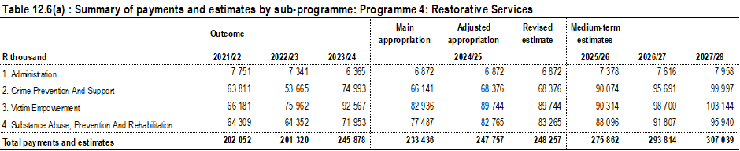
12.4.4 Programme Resource Considerations

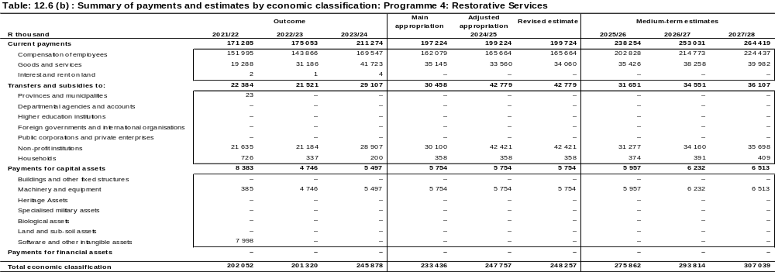
The allocation for the programme increased by 18.2 percent from budget of R233.4 million in 2024/25 to R 275.9 million in 2025/26 financial year due to the CPI baseline increase and reprioritization R3.5 million from goods and services to fully fund the CoE shortfall.
Compensation of Employees budget increased by 25.1 percent or R162.1 million in 2024/25 to R202.8 million 2025/26 financial year due to CPI increase and the reprioritisation of R3.5 million from goods and services to cater for Coe shortfall.
Goods and services budget has increased by 0.8 percent or R35.1 million in 2024/25 to R35.4 million in 2025/26 financial year due the repriorotisation to fully fund CoE shortfall. The budget allocation is for the running of Khuseleka plus contract catering for Seshego Treatment Centre and Polokwane Welfare Services and Secure cares centres. The cost driver for goods and services is the outsourced kitchen services or catering and supply and delivery of perishables for the secure care centres which was considered for the equal share from fiscal sustainability additional allocation for R0.500 million. Food and food supplies received an equal share of R0.500 million under Crime Prevention and Substance Abuse centres.
Transfers and subsides budget increased from R30.1 million in 2024/25 to R31.6 million or 3.9 percent in 2025/26 financial year due to reprioritization within the transfers and subsidies programme. The provision is made for transfers to Non-Profit Organizations rendering services for the department for substance abuse, Gender Based Violence and crime prevention.
Payments for capital assets budget has increased from R5.7 million in 2024/25 to R5.9 million or 3.5 percent in 2025/26 financial year. An amount of R5.9 million under Machinery and Equipment has been set aside for procurement of tools of trade.

12.5 PROGRAMME 5: DEVELOPMENT AND RESEARCH
The aim of this programme is:
- Building safe and sustainable communities through the creation of strong community networks, based on principles of trust and respect for local diversity, and nurturing a sense of belonging and confidence in local people.
- To support NPO registration and compliance monitoring, NPO stakeholder liaison and communication, provide institutional capacity building, manage NPO funding and monitoring and create a conducive environment for all NPO to flourish.
- Manage Social Facilitation and Poverty for Sustainable Livelihood programmes (including EPWP).
- Building safe and sustainable communities through the creation of strong community networks, based on principles of trust and respect for local diversity, and nurturing a sense of belonging and confidence in local people.
- To support NPO registration and compliance monitoring, NPO stakeholder liaison and communication, provide institutional capacity building, manage NPO funding and monitoring and create a conducive environment for all NPO to flourish.
- Manage Social Facilitation and Poverty Alleviation Initiatives for Sustainable Livelihoods programmes (including Expanded Public Works Programmes).
- Create an environment to help young people to develop constructive, affirmative and sustainable relationships while concurrently providing opportunities for them to build their competencies and needed skills to engage as partners in their own development and that of their communities.
- Create an environment to help women to develop constructive, affirmative and sustainable relationships while concurrently providing opportunities for them to build their competencies and needed skills to engage as partners in their own development and that of their communities.
- To promote the implementation of the Population Policy within all spheres of government and civil society through population research, advocacy, capacity building and by monitoring and evaluating the implementation of the policy.

Persistent poverty, unemployment and inequality remain challenges for our country in the post 1994 period. Where there is persistent poverty people experience concurrent capability deprivation including illiteracy, inadequate nutrition and insufficient income livelihood challenges. The COVID-19 pandemic has negatively affected and increased the levels of unemployment, poverty and inequalities in South Africa and other countries of the World.

In the Post-Covid 19 era, unemployment in South Africa increased to a high of 32.5 percent in 2020 with 23 million South Africans pushed into poverty. The increases in unemployment also had a negative impact on the level of poverty and susceptibility to hunger. In 2022, 1 802 051 children in South Africa lived in households affected by hunger. In the same period,60 754 children lived in households which reported hunger. The number of adults living in households that reported hunger in South Africa during 2022 stood at 3 030 794.In Limpopo,98 829 people were in 2022 living in households which reported hunger.

Although the total labour force of the province has shown growth between fourth quarter of 2023 and first Quarter of 2024, 728 000 people were unable to find work within the same period while 521 000 people have given up looking for work.

During the First Quarter of 2024 Limpopo recorded the largest unemployment rate increase nationally from 30.3% at the end of fourth Quarter of 2023 to 32.7% in the first Quarter of 2024.The provincial expanded unemployment rate within the same period also increase by1.1%points from 46.7% to 47.8%.Women and youth constitute the majority amongst the unemployed in the province while the poor and the vulnerable particularly the elderly and children remain susceptible to hunger and other forms of deprivation.

The Department has from 2019 to 2024, provided 57 148 households with access to sustainable livelihoods initiatives through poverty alleviation programmes, while 442 337 individuals accessed food through DSD feeding programmes (centre based). From 2024 to 2029 the programme seeks to continue with initiatives to resolve hunger, unemployment and poverty and strengthen initiatives aimed at empowering vulnerable households, individuals, women and youth.

12.5.1 Measuring the Impact
Impact Statement | Improved quality life for the poor and vulnerable

Key Beneficiaries | - Poor and vulnerable Households  - Poor and vulnerable Individuals (All Ages)  - Vulnerable women (aged between 36 and 69 years)  - Vunerable youth (aged between 18 and 35 years)  - Civil Society Organisations, NPOs, CBOs
Assumptions | Increase in poverty and vulnerability
National Development Plan (NDP) Goals and Objectives 2030 | Social Protection
Limpopo Development Plan (LDP) Objectives 2025-2030 | - Implement targeted poverty alleviation programmes
Medium Term Development Plan (MTDP) 2024-2029 | Strategic Priority 2: Reduce poverty and tackle the high cost of living  Strategic Priority 1: Inclusive Growth and Job Creation
Priority interventions | - The goal of realizing rights of women, youth, persons with disabilities, and children is treated as a cross-cutting  - Women: Gender equality, economic empowerment, reduced gender-based violence, and gender parity in governance  - Youth: Reduced unemployment, access to education and vocational training, support for entrepreneurship, and participation in decision-making  - Persons with Disabilities: Accessible public domains and services, equitable education, increased employment, and responsive legal frameworks  - Strengthen provision of Food Nutrition Security and sustainable livelihoods programmes to the poor and vulnerable.  - Strengthen empowerment and support services to vulnerable and poor with priority on women and youth  - Enhance capacity building of NPOs and Community Development Practitioners  - Intensify Community mobilisation for community development

12.5.2 Measuring Outcomes
Outcome | Outcome indicator | Outcome Baseline 2019 -2024 | Outcome (5) Five Year Target 2025-2030
Increased employment opportunities | EPWP work opportunities created through DSD programmes | 12 931 | 12 500
Reduced poverty and improve livelihood | Individuals accessing food through DSD feeding programmes (centre based) | 442 337 | 83 750
Reduced poverty and improve livelihood | Youths participating in skills development programmes | 4 651 | 3 000
Reduced poverty and improve livelihood | Women participating in empowerment programmes | 81 320 | 85 000

12.5.3 Explanation of Planned Performance over the Five-Year Planning Period
- The contribution of outcomes towards the achievement of the Medium-Term Development Plan (MTDP), the mandate of the institution and priorities of women, children, youth and persons with disabilities, provincial priorities and Science Technology and Innovation (STI) Decadal plan priorities (2023-232) (where applicable).
The outcome on “Reduced poverty and improved livelihoods” shall contribute towards the achievement of MTDP Strategic Priority 2 “Reduce poverty and tackle the high cost of living and Strategic Priority 1” Inclusive Growth and Job Creation”. This will empower women, youth, and persons with disabilities by ensuring that women there is sustained work opportunities as well as empowering youth and women.
The Decadal Plan proposes a transdisciplinary process to analyse, quantify and develop a set of impact measures that can be used to recalibrate, refocus and scale up the contribution of innovation to socio-economic development and expand the human resources capacity for STI. This intervention shall go a long way in keeping with the 4IR for effective service delivery.
- The rationale for the choice of the outcome indicators relevant to the respective outcomes.
The rationale for the choice of the outcome indicators is informed by the outcome “Reduced poverty and improved livelihood” particularly on food insecurity, unemployment for youth, women and persons with disability.
- Explanation of enablers to achieve the five-year targets.
In the next five years the Department shall implement the following enablers to achieve the outcome. Household Change Agents sustainable livelihood approach, Community Capacity enhancement linking cooperatives with markets and gender mainstreaming.

- Explanation of the outcomes’ contribution to the achievement of the impact.

The outcome “Reduced poverty and improved livelihoods” shall contribute towards the achievement of impact “Improved quality of life for the poor and vulnerable” by implementing MTDP Strategic Priorities, LDP priorities and Strategic Plan interventions for Social Protection in line with Chapter 11 of the NDP Vison 2030and SDG Agenda 2030.

12.5.4 Programme Resource Considerations
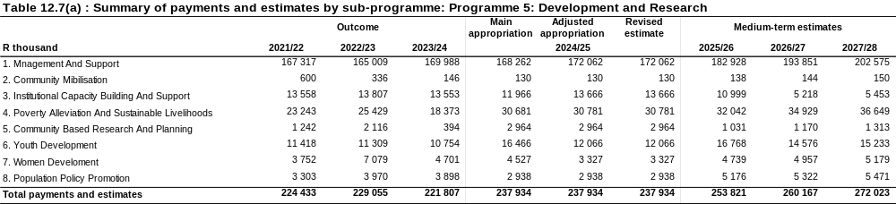
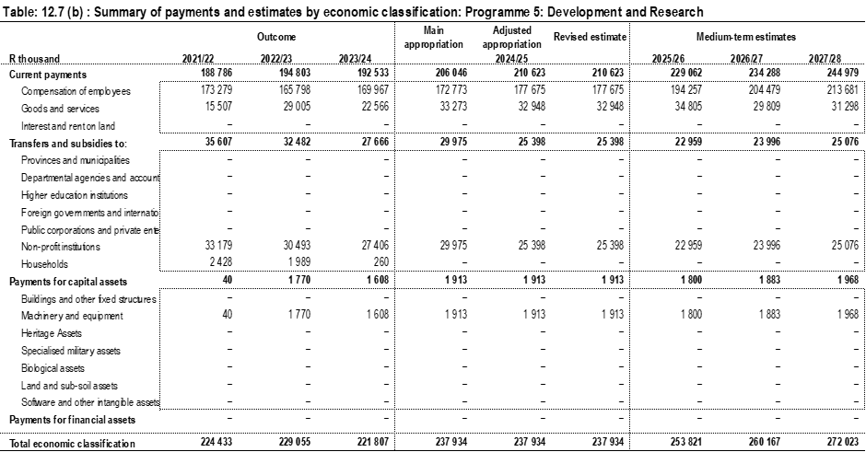
The allocation of the programme increased by 6.7 percent from R237.9 million in 2024/25 financial year to R253.8 million 2025/26, R260.2 million in 2026/27 and R272.0 million in 2027/28 financial year due to the CPI increase and the R7.3 million reprioritized from goods and services to fully fund the CoE pressures emanating from the higher than projected wage agreement.

Compensation of Employees budget increased by R172.8 million in 2024/25 to 12.4 percent or R194.3 million in 2025/26 financial year due the CPI increase and reprioritisation R7.3 million from goods and services to fully fund CoE pressures emanating from the higher than projected wage agreement.
Goods and Services budget increased from R33.3 million in 2024/25 to R34.8 million due to additional of R5,9 million on conditional grant budget of EPWP contract labourers and the reprioritization to CoE shortfall. In addition, the 2025/26 conditional grant allocations have been completed with revision of Expanded Public Works Programme integration or merging of Incentive grant and Integrated grant and consolidation of the allocation to a total of R5.991 million for implementation within goods and services. The main contributor for the increase is due to the correct classification of food relief function shift from transfers and subsidies for an amount of R8.8 million in 2025/26 and R8.4 million in 2026/27 which was partially implemented from 2024/26 adjustment budget appropriation.
Transfers and subsidies budget decreased from R29.9 million in 2024/25 to R22.9 million in 2025/26 financial year due to R8.4 million misclassification for food relief from Transfer and subsidies to goods and services and the budget has been allocated to fund Cooperatives under Poverty Alleviation, Institutional Capacity Building, Youth and Women Development sub-programmes.
Payments for capital assets budget of R1.8 million in 2025/26 financial year set aside provision for procurement of laptops for the community development practitioners.
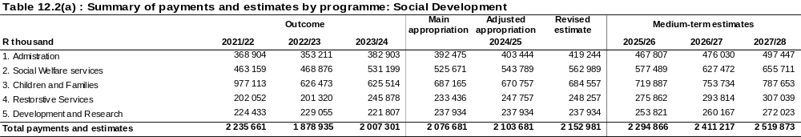
The bulk of the budget is allocated to Children and Families at R719.9 million or 31.4 percent. Social Welfare Services is allocated R577.5 million or 25.2 percent of total budget, Administration budget is at R467.8 million or 20.4 percent of the total budget, Development whereas Restorative Services budget is R275.9 million or 12.0 percent of the total budget and Research is allocated R247.9 million or 10.7 percent of total budget.

The overall budget of the department has limited growth of 10.5 percent from R2.076 billion in 2024/25 to R2.295 billion in 2025/26 considering budget principles of allocative efficiency and guided by priority ranking. Major contributors are the implementation of 2025/26 guidelines on cost containment measures to close the imminent fiscal gap. The budget further responds to the Compensation of Employees pressures emanating from the higher than projected wage agreement.
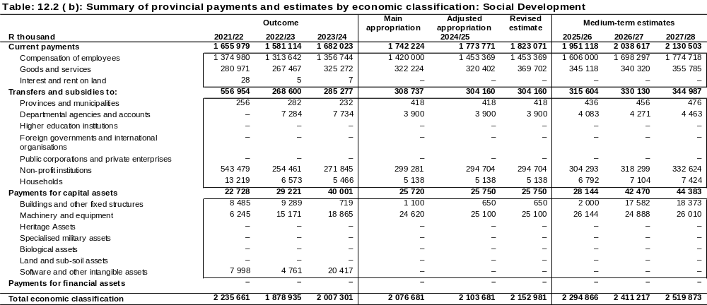
Compensation of Employees (CoE) increases by 13.1 percent from R1.420 billion in 2024/25 to R1.606 billion in 2025/26. The additional allocation is inclusive of R17.0 million as provision responding to CoE pressures emanating from the higher than projected wage agreement. An amount of R168 million has been reprioritised from the total budget as CoE sustainability including R11.0 million from payments of capital assets mainly from building and fixed structures. The budget reprioritisation is from economic classification programmes mainly goods and services and CAPEX to fully fund the CoE head counts shortfall while recovering from fiscal consolidation. The overall budget provision and increase considered the 1.5% pay progression and the estimated 4.4% wage agreement cost and Accelerated Grade Progression for professionals.
Goods and services budget allocation increased by 7.1 percent from the budget of R322.2 million in 2024/25 to R345.1 million in 2025/26 financial year due the reprioritization to fully fund the CoE shortfall. The department employed the zero-based budgeting method for efficient and effective budget distribution considering the limited resources and in endeavour not to compromise service delivery. An amount of R14.0 million has been ring-fenced for implementation of maintenance of capital projects and facilities from the fiscal sustainability allocation for R20.0 million and the R7.0 million has been prioritised for contractual obligation given the identified budget shortfall within all programmes. The additional allocation for fiscal sustainability for R7.0 million has been reprioritised as follows:
- Agency and support /outsourced services = R3.5 million
- Food and food supplies for Children and Youth Care Centres (CYCCs) for R1.0 million, an equal share of R0.500 million under Crime Prevention, Sekutupu Old Aged Home, and for Substance Abuse centres.
- R1.0 million for security services within district offices.
- R0.524 million to audit fees under Corporate Services.
The 2025/26 conditional grant allocations have been completed with revision of Expanded Public Works Programme integration or merging of Incentive grant and Integrated grant and consolidation of the allocation to a total of R6.010 million. An additional provision of R1.4 million to complement the available allocation of R2.6 million from equitable share fund is required. This is to ensure that all the institutions continue to have EPWP participants rendering services in various workstations as per programmes listed in the calculators.

Transfers and subsidies budget allocation has increased from R308.7 million in 2024/25 to R315.6 million in 2025/26 and R 330.1 million in 2026/27 and R 344.9 million in 2027/28 financial years.

Payments for capital assets budget allocation has increased from R25.7 million in 2024/25, by R28.1 million in 2025/26 and R42.4 million in 2026/27 and R44.3 million in 2027/28 financial year and the funds were reprioritised to fully fund the CoE. The budget for building and fixed structures is not increasing except for the annual reprioritisation towards implementation of maintenance of facilities within goods and services given the progress on assessed maintenance plan by Public Works. An amount of R11.0 million has been reprioritised to CoE programme and R2.0 million to add to the ring- fenced allocation for maintenance of capital projects under goods and services.

13. Key Risks
NO. | OUT COMES | RISKS | MITIGATION
01 | Safer communities and increased business confidence | Secondary victimization of GBVF victims | - Full Implementation of VEP information System by all stakeholders
02 | Safer communities and increased business confidence | Continuous re-offending of children | - Strengthen the implementation of aftercare and reintegration services
03 | Reduced poverty and improve livelihood | Funded NPOs not complying with DSD Norms and standards | - Strengthen, monitor and capacitate NPOs to ensure compliance with Norms and Standards
04 | Reduced poverty and improve livelihood | Less work opportunities created | - Re-prioritize budget to create more work opportunities.
05 | Reduced poverty and improve livelihood | Decrease in the number of women participating in empowerment programmes | - Linking women with job creation and food security initiatives
06 | Functional, efficient, and integrated sector | Non-compliance with the procurement plan | - Monitor the implementation of the procurement plan
07 | Functional, efficient, and integrated sector | Nonadherence to payment of suppliers within 30 days | - Track progress of payment of invoices received.
08 | Functional, efficient, and integrated sector | Failure to resolve AGSA audit findings | - Monitor implementation of clean audit strategy
09 | Functional, efficient, and integrated sector | Inadequate e-leave management system | - Implement provincial e-leave management systems
10 | Functional, efficient, and integrated sector | Non-Adherence to Policies on Recruitment and selection | - Strengthen capacity on HR recruitment and selection

14. Public Entities
Name of Public Entity | Mandate | Outcomes
N/A | N/A | N/A

Part D: Technical Indicator Description (TID)

15. PROGRAMME 1: ADMINISTRATION
Indicator Title | Percentage of women in SMS positions employed (level 13-16)
Definition | Percentage of females in Senior Management position employed
Source of data | PERSAL report on appointments
Method of Calculation / Assessment | Number of female SMS members divide by total number of SMS members multiply by hundred (100)
Assumptions | - There will be vacant positions at SMS level which will enable the department to fill with female candidates.  - Women who meet the requirements for SMS positions will apply
Disaggregation of Beneficiaries (where applicable) | Female  Male
Spatial Transformation (where applicable) | All Districts
Desired performance | An increased percentage number for women in SMS positions are employed
Indicator Responsibility | Chief Director: Corporate Services

Indicator Title | Percentage people with disabilities employed
Definition | The percentage of People with Disabilities employed in the department
Source of data | PERSAL report on people with disabilities employed
Method of Calculation / Assessment | Number of persons with disabilities divide by total number of employees multiply by hundred (100)
Assumptions | - There will be vacant positions which will enable the department to fill with candidates with disabilities.  - Persons with disabilities who meet the requirements for advertised positions will apply
Disaggregation of Beneficiaries (where applicable) | The department will prioritise the appointment of people with disabilities during the Recruitment Process
Spatial Transformation (where applicable) | All Districts
Desired performance | An increased percentage number for People with Disabilities are employed
Indicator Responsibility | Chief Director Corporate Services

Indicator Title | Number of material audit findings issued by the AGSA
Definition | The indicator reflects the number of material audit findings issued by the AGSA at the end of each financial year
Source of data | Report of the Auditor General on the Department’s Annual Report
Method of Calculation / Assessment | Simple count
Assumptions | The department will remedy the findings for 2023/24 and reduce the number of material findings until there are zero findings.
Disaggregation of Beneficiaries (where applicable) | N/A
Spatial Transformation (where applicable) | N/A
Desired performance | Number of material findings in the Report of the Auditor General are be as low as possible
Indicator Responsibility | Chief Financial Officer (CFO)

Indicator Title | Percentage of procurement spent from designated groups
Definition | This indicator tracks amount spent on procurement targeting designated group
Source of data | Preferential Procurement reports from CSD
Method of Calculation / Assessment | Amount spent on enterprises owned by designated groups on bids and quotations awarded divide by the total amount of bids and quotations awarded equals to percentage of procurement of bids and quotations awarded to by designated groups owned enterprises.
Assumptions | - There procurement plan of the departments responsible for transversal contracts are aligned to the departmental targets with respect to enterprises owned by designated individuals  - Enterprises owned by designated individuals bid and responsive to tenders and quotations issued by the department
Disaggregation of Beneficiaries (where applicable) | Women - 40%  Youth - 30%  People with Disabilities – 7%  Military Veterans – 5%
Spatial Transformation (where applicable) | All districts
Desired performance | Previously disadvantaged individuals benefiting from preferential procurement strategy
Indicator Responsibility | Chief Financial Officer (CFO)

16. PROGRAMME 2: SOCIAL WELFARE SERVICES
Indicator Title | Older persons accessing services
Definition | This indicator counts older persons aged 60 and above who are accessing community-based care services and those in residential facilities.
Source of data | Dated and signed register or database with names, surnames and ID numbers, disaggregated by gender, disability status and district.
Method of Calculation / Assessment | Simple count
Assumptions | Older Persons are in need residential and active ageing programmes
Disaggregation of Beneficiaries (where applicable) | - Older persons: (100%)  - (68%) Female  - (32%) Male  - (10%) Older persons with disabilities
Spatial Transformation (where applicable) | Community based care and support service centres and residential facilities in the province.
Desired performance | Increased access in community-based care and support services and residential facilities to older persons aged 60 and above.
Indicator Responsibility | Chief Director: Social Welfare Services

Indicator Title | Persons with disabilities accessing services
Definition | This indicator counts the number of persons with disabilities accessing residential facilities and protective workshops funded and un-funded managed by NPOs
Source of data | Dated and signed register or database with names, surnames and ID numbers, disaggregated by gender, disability status and district.
Method of Calculation / Assessment | Simple count
Assumptions | Persons with disabilities in need of residential and social life skills services
Disaggregation of Beneficiaries (where applicable) | Persons with disabilities: (100%)  - (68%) Female  - (32%) Male
Spatial Transformation (where applicable) | Residential facilities and protective workshops in the province.
Desired performance | Increased access in the Protective workshops and decreased access in Residential facilities
Indicator Responsibility | Chief Director: Social Welfare Services

Indicator Title | People infected and affected by HIV and AIDS accessing services
Definition | This indicator counts the number of people affected and infected by HIV and AIDS accessing Social and behaviour change programmes including psychosocial support services.
Source of data | Dated and signed register or database with names, surnames and ID numbers, disaggregated by gender, disability status and district.
Method of Calculation / Assessment | Simple count
Assumptions | There is high prevalence of social ills contributing to the increase of HIV and AIDS
Disaggregation of Beneficiaries (where applicable) | Female: 60%  Male: 40%  Disability:5%  Youth: 60%  Adult:40%
Spatial Transformation (where applicable) | NPOs and DSD service points in the Province
Desired performance | Increase in the coverage of beneficiaries reached through social behaviour change programmes including psychosocial support services.
Indicator Responsibility | Chief Director: Social Welfare Services

Indicator Title | Number of beneficiaries who benefitted from DSD social relief programmes
Definition | This indicator refers to the total number of individuals who benefited from DSD social relief programmes. It also refers to all forms of relief, which includes amongst others; paupers burial, disaster relief including food parcels, psycho-social support and other forms of material assistance.
Source of data | Dated and signed register or database with names, surnames and ID numbers, disaggregated by gender, disability status and district.
Method of Calculation / Assessment | Simple count
Assumptions | There is prevalence of trauma and distress in communities
Disaggregation of Beneficiaries (where applicable) | Female: 60%  Male: 40%  Disability:5%  Youth: 30%  Adult:70%
Spatial Transformation (where applicable) | NPOs and DSD service points in the Province
Desired performance | Increase in the beneficiaries accessing DSD social relief of distress programmes
Indicator Responsibility | Chief Director: Social Welfare Services

17. PROGRAMME 3: CHILDREN AND FAMILIES
Indicator Title | Family members participating in family preservation services.
Definition | This indicator counts the total number of family member/s who participated in family preservation services during the quarter. This includes parenting and reunification services.
Source of data | Dated and signed register or database with names, surnames and ID numbers, disaggregated by gender, disability status and district.
Method of Calculation / Assessment | Simple count
Assumptions | Families are in need of support given the prevailing social ills
Disaggregation of Beneficiaries (where applicable) | Female: 53%  Male: 47%  Disability: 2%
Spatial Transformation (where applicable) | NPOs and DSD service points in the Province
Desired performance | Increase in the coverage of family members participating in Family Preservation Services
Indicator Responsibility | Chief Director: Social Welfare Services

Indicator Title | Children accessing care and protection services
Definition | This indicator counts the total number of children who accessed psychosocial support services. This includes reported cases of child abuse, children in foster care, children placed in Child and Youth Centres, children accessing partial care facilities and children accessing services in community-based prevention and early intervention services. Children in foster care and Child and Youth Care Centres include those whose orders have been extended in terms of section 176 of the Children’s Act 38 of 2005 which allows them to remain in alternative care until the end of the year in which they reach 21 years excluding children in secure care centres
Source of data | Dated and signed register or database with names, surnames and ID numbers, disaggregated by gender, disability status and district.
Method of Calculation / Assessment | Simple count
Assumptions | There are orphans and vulnerable children in communities
Disaggregation of Beneficiaries (where applicable) | 100% Children  Female: 80  Male: 20  Disability:1%
Spatial Transformation (where applicable) | NPOs in the Province
Desired performance | Increased number of children accessing services through community-based prevention and early intervention programmes
Indicator Responsibility | Chief Director: Social Welfare Services

18. PROGRAMME 4: RESTORATIVE SERVICES
Indicator Title | People reached through social crime programmes
Definition | This indicator counts the number of persons in conflict with the law reached through developmental programmes.
Source of data | Dated and signed register or database with names, surnames and ID numbers, disaggregated by gender, disability status and district.
Method of Calculation / Assessment | Simple count
Assumptions | There is high prevalence of social ills in communities
Disaggregation of Beneficiaries (where applicable) | Female: 30%  Male: 70%  Disability: 1%
Spatial Transformation (where applicable) | NPOs and DSD service points in the Province
Desired performance | Increase in the number of persons reached through social crime programmes
Indicator Responsibility | Chief Director: Social Welfare Services

Indicator Title | Victims of violence accessing psychosocial services
Definition | This indicator counts the number of victims of violence (GBV, domestic violence and femicide) who accessed support services in Victim Empowerment Programme service centers. These include services rendered at Shelters, Green and White Doors Houses, Welfare Organizations, NPOs, NGOs, Department of Social Development(DSD) service points, Thuthuzela Care Centers and other service organizations funded and unfunded by DSD.
Source of data | Dated and signed register or database with names, surnames and ID numbers, disaggregated by gender, disability status and district.
Method of Calculation / Assessment | Simple count
Assumptions | There is a high prevalence of social ills
Disaggregation of Beneficiaries (where applicable) | Female: 90%  Male: 10%  Disability: 1%
Spatial Transformation (where applicable) | NPOs and DSD service points in the province
Desired performance | Increased number of victims of violence who assessed support services
Indicator Responsibility | Chief Director: Social Welfare Services

Indicator Title | People reached through substance abuse programmes
Definition | This indicator counts the number of people who attended substance abuse programmes and treatment
Source of data | Dated and signed register or database with names, surnames and ID numbers, disaggregated by gender, disability status and district.
Method of Calculation / Assessment | Simple count
Assumptions | There is a high prevalence of social ills
Disaggregation of Beneficiaries (where applicable) | Female: 30%  Male: 70%  Disability: 1%
Spatial Transformation (where applicable) | NPOs and DSD service points in the Province
Desired performance | Increased in persons reached through substance abuse programmes
Indicator Responsibility | Chief Director: Social Welfare Services

19. PROGRAMME 5: DEVELOPMENT AND RESEARCH
Indicator Title | Work opportunities for the poor and vulnerable provided through DSD Programmes
Definition | The indicator counts the number of jobs created through EPWP, social services professionals graduates, DSD Empowerment Programmes, periodic contracts which includes but not limited to the following: Security services, catering, frail care services. These contracts should be for a period of not less than 3 years and are concluded through competitive bidding. This excludes quotation sourcing. Payment of salaries and /or stipend must be in line with specific sectorial determination.
Source of data | Data base of jobs created
Method of Calculation / Assessment | Count number of jobs created
Assumptions | More unemployed youth in the province have requisite skills but without relevant experience to gain access to job market.
Disaggregation of Beneficiaries (where applicable) | - Youth: 60%  - Women: 40%  - Disabilities:7%
Spatial Transformation (where applicable) | 90% of DSD facilities and services are located in rural areas
Desired performance | Increased access to employment by young people between the age 18 and 35 years.
Indicator Responsibility | Chief Director Development and Research

Indicator Title | Number of people accessing food through DSD feeding programmes (centre- based)
Definition | This indicator counts the number of people who accessed nutritious food through DSD centre-based feeding programmes such as CNDCs.
Source of data | Dated and signed registers with names, surnames and ID numbers
Method of Calculation / Assessment | Simple count
Means of verification | List of people
Assumptions | Unemployed, poor and food insecure individuals will be willing to participate in DSD feeding programmes (centre- based)
Disaggregation of Beneficiaries | - Female:60%  - Male:40%  - Disability:2%
Spatial Transformation | All Districts
Calculation Type | Cumulative year to date
Desired performance | Decreased food insecurity incidents within vulnerable households
Indicator Responsibility | Programme Managers

Indicator Title | Youth aged 18 to 35 trained through skills Development Programmes
Definition | The indicator counts the number of youth aged 18-35 years who attended accredited and non-accredited training funded through DSD skills development programmes. (National Youth Service, entrepreneurship, vocational training and any other empowerment initiatives)
Source of data | Data base of trained youth aged 18-35
Method of Calculation / Assessment | Simple count
Assumptions | Unemployed youth will actively participate in skills development programmes.
Disaggregation of Beneficiaries (where applicable) | - Youth: 100%  - Female: 60%  - Male : 40%  - Disabilities:7%
Spatial Transformation (where applicable) | DSD targets young people from poor communities in all districts
Desired performance | Increased skills levels requisite for access to job markets and SMMEs development for young people between the age 18 and 35 years.
Indicator Responsibility | Chief Director Development and Research

Indicator Title | Women participating in empowerment programmes
Definition | This indicator counts the number of women participating in empowerment programmes. Empowerment means gaining skills and knowledge to access social and economic opportunities for sustainable livelihoods.
Source of data | Data base of empowered women
Method of Calculation / Assessment | Simple count
Assumptions | Targeted women will be willing to participate in the departmental empowerment programmes
Disaggregation of Beneficiaries (where applicable) | - Women 100%  - Young women: 20 %  - Youth with Disabilities: 7%
Spatial Transformation (where applicable) | DSD provides services to poor communities in all districts
Desired performance | Increased levels of empowerment for women with requisite skills and exposure for easy access to job markets and SMMEs development
Indicator Responsibility | Chief Director Development and Research

Annexure A: NSDF and the District Development Model: Infrastructure Projects
Area of Intervention in the NSDF and DDM | Five Year Planning Period
Area of Intervention in the NSDF and DDM | Project Name | Project Description | Budget Allocation | District Municipality | Specific Location | Project Leader | Social Partners | Longitude  (East/West/+x) | Latitude  (North/South/-Y)
Water | - | - | - | - | - | - | - | - | -
Sanitation | - | - | - | - | - | - | - | - | -
Roads | - | - | - | - | - | - | - | - | -
Storm Water | - | - | - | - | - | - | - | - | -
Electricity | - | - | - | - | - | - | - | - | -
Environmental Management | - | - | - | - | - | - | - | - | -

Annexure B: Processes for the Development of the Departmental Strategic Plan 2025-2030 and Annual Performance Plan 2025/2026
Strategic Activities and Significance | Participants | Date of the Sessions | Venue for the Sessions
Financial management extended branch meeting | CFO and Finance | 10-12 July 2024 | Palala Lodge
Development and Research Symposium | Chief Directorate, Managers and Districts | 15-17 July 2024 | Warmbaths Aventura
Social Work Services extended branch meeting | Chief Directorate, Managers and Districts | 17-19 July 2024 | Swadini Resort
Corporate extended branch meeting | Chief Directorate, Directors and Deputy Directors | 24-26 July 2024 | Palala Lodge
Departmental Strategic Planning session | Executive /Senior Management, provincial and District Programme Coordinators | 9-11 September 2024 | Karibu Resort
Presentation of draft SP 2025-2029, Revised APP 2024/25 and draft APP 2025/26 | HOD and Senior Management | 14 October 2024 | Provincial Office
Presentation of draft SP 2025-2029, Revised APP 2024/25 and draft APP 2025/26 to the EA to sign off | HOD, CFO and Chief Directors | 14 October 2024 | Provincial Office
Submission of the draft SP 2025-2029, Revised APP 2024/25 and draft APP 2025/26 to the OtP | Signed by Programme Managers (Chief Directors), CFO, Head of Planning, HOD, and signed off by the Executive Authority | 15 October 2024 | Provincial Office of the Premier
Technical Alignment session | The department aligned its SP 2025-2030 and APP 2025-26 | 12-13 December 2024 | DoH Auditorium
Refining theories of change per programme | The theories of change updated to align with new priorities
Refining theories of change per programme | The theories of change updated to align with new priorities | 21 January 2025  23 January 2025  7 February 2025 | Hybrid Ndou Boardroom
Feedback session on SP and APP assessment results with OTP and DPME | All departments, programme managers and Planners | 3 - 4 February 2025 | Bolivia Lodge
Sector Strategic Planning Session | National DSD, Provincial DSD, SASSA, NDA, CRO’s, and Planners | 27 -28 February 2025 | OR Tambo Holiday Inn
Departmental Strategic Planning session | Executive /Senior Management, provincial and District Programme Coordinators | 3 – 4 March 2025 | Euphoria Golf Estate
Briefing of the executive authority on the final plans and sign off | Executive Authority, HOD, CFO and Senior Management | 6 March 2025 | MEC Office
Submission of the SP and APP at the Legislature, OTP and NDSD | Strategic Planning and M&E | 7 March 2025 | Provincial Legislature
Tabling at the Provincial Legislature | Executive Authority, HOD, CFO and Senior Management | 11 March 2025 | Provincial Legislature
Implementation of the SP 2025-2030 and APP 2025/26 by department | All programmes and sub programmes | 1 April 2025 | Limpopo DSD Head Office, Districts and Sub Districts

PR 53/2025
ISBN: 978-1-77997-562-1

www.municipalities.co.za/provinces

